## Gym Management system

### B.Sc. (Math’s, Physics, Computer Science) Dissertation Submitted to St. Francis College for Women in partial fulfilment of the requirements for the award of the Degree of

**Bachelor Of Science By**

### Sai Prathyusha 121319043026

**Under the guidance of Ms. Savithri**



### Department Of Computer Science

**St. Francis College for Women Begumpet, Hyderabad-500016**

### (Autonomous and affiliated to Osmania University) March 2022



**CERTIFICATE**

This is to certify that the bonafide project work titled **GYM MANAGEMENT SYSTEM** has been carried out by **Sai Prathyusha** bearing roll no. **121319043026** towards partial fulfilment of the requirements for the award of Degree of Bachelor’s **Computer science** from St. Francis College for Women, Begumpet in the academic year **2021-2022.**

Internal Examiner External Examiner

**Head of Department**

Controller of Examination

The current study “**Gym Management System**” has been carried out under supervision of Ms. Savithri, Asst Professor, Department of Computer Science, St. Francis College for Women. We hereby declare that the present study that has been carried out by us, Harshita and Sai Prathyusha during the period 2021-2022 is original and no part of it has been carried out prior to this date.

Date:

Signature of Candidate:

Finding a good gym in less time can sometimes seems like an impossible task. You should first search then visit for enquiry of availability and services and after a long struggle you go with the booking or might not.

“**Gym Management System**” is a web-based gym management application with package booking functionality. In this system user can make a package booking online and view the package information in detail. They can do a gym tour virtually and can also see various equipment’s present in gym. They can become a member of the gym and enjoys multiple services. By becoming a member, they can view yoga videos, zumba videos, diet plan. User sees the details of gym and can contact the gym authority. A google map is also provided for allowing users to find available route through driving, public transportation or walking.

In this system, owner give details of the services they offer and also describe the services in detail.

This software help website admin to see all the details in brief like login, bookings, payments, messages received and trainer data.

Based on the result, it was found online booking is more convenient than manual system. As it is easier and reduce time taking process. So, because of this gym management system many users can manage their good health even in their busy schedules.

The accomplishment of this project has been enriching and a learning experience. We therefore take the opportunity to express our gratitude to all those who have made it possible for us to complete the project.

We respect and thank the Head of department, Ms Padma Sree, for giving us an opportunity to work on such an interesting project which gave us a chance to put into practice all the knowledge that we gained during the three years of our college. We are extremely thankful to our project guide Ms Savithri, Asst professor, for her assistance, guidance and encouragement throughout the months of research, data collection and project compilation.

Furthermore, we would like to acknowledge with much appreciation the crucial role of our classmates who were constantly motivating in completing the project. Also, we would like to thank all the computer lab assistants who gave the permission to use all required equipments and the necessary materials to complete the project.

|  |  |  |
| --- | --- | --- |
| Chapter No. | Title | Page No. |
| 1 | INTRODUCTION | 1 |
| 1.1 | OBJECTIVES | 1 |
| 1.2 | PURPOSE | 2 |
| 1.3 | SCOPE AND APPLICABILITY | 2 |
| 1.4 | ACHIEVEMENTS | 3 |
| 1.5 | ORGANISATION OF REPORT | 3 |
| 2 | SURVEY OF TECHNOLOGIES | 4-8 |
| 3 | REQUIREMENTS AND ANALYSIS | 9 |
| 3.1 | PROBLEM DEFINITION | 9 |
| 3.2 | HARWARE REQUIREMENT | 10 |
| 3.3 | SOFTWARE REQUIREMENT | 11 |
| 3.4 | CONCEPTUAL MODELS | 11-14 |
| 4 | IMPLEMENTATION AND RESULT | 15 |
| 4.1 | CODING DETAILS | 15-83 |
| 4.2 | DATABASE | 84-85 |
| 4.3 | RESULTS | 86-111 |
| 5 | CONCLUSION | 111 |
| 5.1 | CONCLUSION | 112 |
| 5.2 | LIMITATIONS OF SYSTEM | 112 |
| 5.3 | FUTURE SCOPE | 112-113 |
| 5.4 | REFERENCES | 113 |

|  |  |  |
| --- | --- | --- |
| Table No. | Title | Page No. |
| 4.2.1 | ADMIN TABLE | 88 |
| 4.2.2 | SIGN UP TABLE | 88 |
| 4.2.3 | BOOKING TABLE | 88 |
| 4.2.4 | PAYMENT TABLE | 89 |
| 4.2.5 | CONTACT TABLE | 89 |
| 4.2.6 | TRAINER TABLE | 89 |
| 4.2.7 | LEAVE TABLE | 89 |

**LIST OF FIGURES**

|  |  |  |
| --- | --- | --- |
| Figure No. | Title | Page No. |
| 3.4.1 | USE CASE DIAGRAM | 12 |
| 3.4.2 | CLASS DIAGRAM | 13 |
| 3.4.3 | ACTIVITY DIAGRAM | 14 |

# CHAPTER 1 INTRODUCTION

## CHAPTER 1 INTRODUCTION

With tremendous increase in technology, information technology is a fast-developing field. Technology which is in vogue today might become redundant tomorrow. This ever-changing scenario makes it possible to provide the latest and most modern IT solutions to various business and institutions.

We are doing our project on “**Gym Management System**”. There is a need for efficient management of a network-based system for handling bookings.

This project is an endeavour to provide a solution to this. The proposed system enables an administrator to keep track of user bookings and maintaining records. Also provides data of trainers.

Thus, the project is a sincere effort in simplifying the task of administrators in an easily usable format.

We finalized the project and hence planned to develop this system using HTML, CSS for front end and PHP, MySQL for back end.

* 1. **OBJECTIVES**
     + The main objective of Gym Management System is to save time and complexity of work at Gym. This system is helpful for all persons because the uses of this application are easy. By this user can see all types of services for themselves.
     + This system will store all the basic data processing needs the gym management.
     + The admin has a privilege to view any database at any time and make the required changes, if necessary.
     + Overcome the major limitations of the existing enabling effective management of the user details thereby improving the performance.
     + Proper monitoring of the processes from user registration to booking.
     + Easy retrieval of data will be made possible.
     + To develop a user-friendly system that requires minimal user training.
     + To develop easy-to-use application that handles the user-management relationship in an effective manner.

### PURPOSE

**The main purpose of this website is to:**

* + - To evaluate best solution for online package booking and manage the same.
    - Provide a single environment from where an administrator can interact with the user within the network.
    - Provide information regarding the number of package services running on the gym management system.
    - To provide an upgrade support for the gym management system resources.
    - Easy bookings and payment options.
    - To provide a complete gym and recreation facility system program which looks after all users and activities.
    - To provide good quality of services to users from gym managers.

### SCOPES AND APPLICABILITY

The gym management system is highly flexible one and is well efficient to make easy interactions with the users.

The key focus is given on data records, as the project is online and will be storing, retrieving from database.

The speed and accuracy will be maintained in a proper way. Scope is an individual that involve in some module in the gym management system.

As the technology and the passion of being muscular and healthy is increasing day by day. So, the need for a well-organized, computer base Gym Management System has become the need of society and the gymnasium industry.

The future depends on gym business. The change that will happen is that the gym, health clubs and spa businesses will merge as one and has all the three services offered by qualifying people in these fields.

There is a huge amount of demand for muscular and healthy across all age group and especially with young boys and girls. They participate in various competitions such as sports, modelling, etc which requires a good healthy body.

The user should be punctual and maintain a continuity for positive growth then only their hard work will pay off.

### ACHIEVEMENTS

The end result of this project is to build a fully functional Gym Management System website. In order to achieve this, theoretically and conceptual understanding of programming languages such as PHP, Java Script was required. Through this project, we have learned a lot of things, mainly how a web application should be developed and presented. Also, it made us learn in depth about concepts like CSS, HTML, Database management, etc. This project helped us gain an advance understanding of the subjects we have learned earlier like HTML, CSS and also helped in understanding how helpful technology is and can be used to develop creative, useful and beneficial products, indeed to help today’s generation in various ways. It gave us confidence about our knowledge and skills and taught us how to implement our theoretical knowledge into practical use. It was a good leaning experience with ups and downs.

### ORGANIZATION OF REPORT

The remaining chapters in this project shows the actual implementation of the project and the modules involved that we have been explaining about in the sections. The database, coding and outputs will give a clear understanding of the project.

Chapter 1- Introduction to project

Chapter 2- Various technologies used to develop this website Chapter 3- About the flow of website in the form of UML diagrams Chapter4- User Interface, code and database.

Chapter 5- Conclusion, Limitations, Future scope and reference of the project

# CHAPTER 2 SURVEY OF TECHNOLOGIES

## CHAPTER-2 SURVEY OF TECHNOLOGIES

The various technologies used for the entire project are mentioned below:

* 1. **Hyper Text Markup Language (HTML):**

HTML is the set of mark-up symbols or codes inserted in a file intended for display on a World Wide Web browser page. The mark-up tells the Web browser how to display a Web page's words and images for the user. Each individual mark-up code is referred to as an element (but many people also refer to it as a tag). Some elements come in pairs that indicate when some display effect is to begin and when it is to end.

Web browsers can read HTML files and compose them into visible or audible web pages. Browsers do not display the HTML tags and scripts, but use them to interpret the content of the page. HTML describes the structure of a website semantically along with cues for presentation, making it a markup language, rather than a programming language.HTML elements form the building blocks of all websites. HTML allows images and objects to be embedded and can be used to create interactive forms. It provides a means to create structured documents by denoting structural semantics for text such as headings, paragraphs, lists, links, quotes and other items. It can embed scripts written in languages such as JavaScript which affect the behaviour of HTML web pages.

Web browsers can also refer to Cascading Style Sheets (CSS) to define the look and layout of text and other material. The World Wide Web Consortium (W3C), maintainer of both the HTML and the CSS standards, encourages the use of CSS over explicit presentational HTML.

### Cascading Style Sheets (CSS):

CSS is a simple design language intended to simplify the process of making web pages presentable. CSS is a style sheet language used for describing the look and formatting of a document written in a mark-up language. While most often used to change the style of web pages and user interfaces written in HTML and XHTML.CSS is designed primarily to enable the separation of document content from document presentation, including elements such as the layout, colours and fonts.

CSS makes it possible to separate presentation instructions from the HTML content in a separate file or style section of the HTML file. The CSS specification describes a priority scheme to determine which style rules apply if more than one rule matches against a particular element. In this so-called cascade, priorities or weights are calculated and assigned to rules, so that the results are predictable. The CSS specifications are maintained by the World Wide Web Consortium (W3C).

CSS is used to define styles for your web pages, including the design, layout and variations in display for different devices and screen sizes. CSS removed the style formatting from the HTML page. CSS saves a lot of work.

### DHTML (DYNAMIC HTML):

DHTML stands for Dynamic HTML, it is totally different from HTML. The browsers which support the dynamic HTML are some of the versions of Netscape Navigator and Internet Explorer of version higher than 4.0. The DHTML is based on the properties of the HTML, Java Script, CSS, and DOM (Document Object Model which is used to access individual elements of a document) which helps in making dynamic content. It is the combination of HTML, CSS, JS, and DOM. The DHTML make use of Dynamic object model to make changes in settings and also in properties and methods. It also makes uses of Scripting and it is also part of earlier computing trends.

DHTML allows different scripting languages in a web page to change their variables, which enhance the effects, looks and many others functions after the whole page have been fully loaded or under a view process, or otherwise static HTML pages on the same. But in true ways, there is noting that as dynamic in DHTML, there is only the enclosing of different technologies like CSS, HTML, JS, DOM, and different sets of static languages which make it as dynamic. DHTML is used to create interactive and animated web pages that are generated in real-time, also known as dynamic web pages so that when such a page is accessed, the code within the page is analysed on the web server and the resulting HTML is sent to the client’s web browser.

Following are some major key features of DHTML:

* + - Tags and their properties can be changed using DHTML.
    - It is used for real-time positioning.
    - Dynamic fonts can be generated using DHTML.
    - It is also used for data binding. It makes a webpage dynamic and be used to create animations, games, applications along with providing new ways of navigating through websites.
    - The functionality of a webpage is enhanced due to the usage of low-bandwidth effect by DHTML.
    - DHTML also facilitates the use of methods, events, properties, and codes

### JavaScript:

JavaScript (JS) is a light-weight object-oriented programming language which is used by several websites for scripting the webpages. It is an interpreted, full-fledged programming language that enables dynamic interactivity on websites when applied to an HTML document.

JavaScript is a very powerful client-side scripting language. JavaScript is used mainly for enhancing the interaction of a user with the webpage. In other words, you can make your webpage livelier and more interactive, with the help of JavaScript.

It is a dynamic computer programming language. It is most commonly used as part of Web browsers, whose implementations allow client-side scripts to interact with the user, control the browser, communicate asynchronously, and alter the document content that is displayed. It is also used in server-side network. JavaScript is classified as a based scripting with dynamic typing and first-class functions. JavaScript is also used in environments that aren't Web-based, such as PDF documents, site-specific browsers, and desktop widgets.

### Hypertext Pre-Processor (PHP):

The PHP Hypertext Preprocessor (PHP) is a programming language that allows web developers to create dynamic content that interacts with databases. PHP is basically used for developing web-based software applications.

PHP started out as a small open-source project that evolved as more and more people found out how useful it was. Rasmus Lerdorf unleashed the first version of PHP way back in 1994.

* + - PHP is a recursive acronym for "PHP: Hypertext Preprocessor".
    - PHP is a server-side scripting language that is embedded in HTML. It is used to manage dynamic content, databases, session tracking, even build entire e-commerce sites.
    - It is integrated with a number of popular databases, including MySQL, PostgreSQL, Oracle, Sybase, Informix, and Microsoft SQL Server.
    - PHP is pleasingly zippy in its execution, especially when compiled as an Apache module on the Unix side. The MySQL server, once started, executes even very complex queries with huge result sets in record-setting time.
    - PHP supports a large number of major protocols such as POP3, IMAP, and LDAP. PHP4 added support for Java and distributed object architectures (COM and CORBA), making n-tier development a possibility for the first time.
    - PHP is forgiving: PHP language tries to be as forgiving as possible.
    - PHP Syntax is C-Like.
    - Five important characteristics of PHP are simplicity, efficiency, security, flexibility, and familiarity.
    - PHP performs system functions, i.e. from files on a system it can create, open, read, write, and close them.
    - PHP can handle forms, i.e. gather data from files, save data to a file, through email you can send data, return data to the user.
    - You add, delete, modify elements within your database through PHP.
    - Access cookies variables and set cookies.
    - Using PHP, you can restrict users to access some pages of your website.
    - It can encrypt data.

### SERVER USED

* + 1. **XAMPP SERVER**

XAMPP is a cross-platform web server that is free and open-source. XAMPP is a short form for Cross-Platform, Apache, MySQL, PHP, and Perl. XAMPP is a popular cross-platform

web server that allows programmers to write and test their code on a local webserver. It was created by Apache Friends, and the public can revise or modify its native source code. It includes MariaDB, Apache HTTP Server, and interpreters for PHP and Perl, among other computer languages. Because of XAMPP’s simplicity of deployment, a developer can quickly and easily install a WAMP or LAMP stack on an operating system, with the added benefit that common add-in apps like WordPress and Joomla can also be loaded.

* + - * XAMPP is simply a local host or server.
      * This local server runs on your personal computer, whether it’s a desktop or a laptop.
      * It is used to test clients or websites before publishing them to a remote web server.
      * On a local computer, the XAMPP server software provides a suitable environment for testing MYSQL, PHP, Apache, and Perl projects. Because most real-world web server deployments share the same components as XAMPP, moving from a local test server to a live server is straightforward.

### DATABASE USED

* + 1. **MySQL**

MySQL is an open-source relational database management system (RDBMS); in July 2013, it was the world's second most widely used RDBMS, and the most widely used open-source client–server model RDBMS. MySQL is a very powerful program in its own right. It handles a large subset of the functionality of the most expensive and powerful database packages. The MySQL development project has made its source code available under the terms of the GNU General Public License, as well as under a variety of proprietary agreements. MySQL was owned and sponsored by a single for-profit firm, the Swedish company MySQL AB, now owned by Oracle Corporation.

MySQL is a popular choice of database for use in web applications, and is a central component of the widely-used LAMP open-source web application software stack (and other "AMP" stacks). LAMP is an acronym for "Linux, Apache, MySQL, Perl/PHP/Python". Free- software open-source projects that require a full-featured database management system often use MySQL on all platforms except Windows, MySQL ships with no GUI tools to administer MySQL databases or manage data contained within the databases. Users may use the included command line tools, or install MySQL Workbench via a separate download. Many third-party GUI tools are also available.

Once MySQL server is up and running, one can connect to it as the super user root with the MySQL client.

Some Basic Operations with MySQL:

* + - * Creating a new database. Use a CREATE DATABASE statement.
      * Creating a table inside a database. The USE statement tells MySQL to use pets as the default database for subsequent statements. Next, create a table with a CREATE TABLE statement.
      * Adding records into a table. Use, for example, an INSERT...VALUES statement.
      * Retrieving records from a table. Use a SELECT statement, and “*” to match all columns.

### PHP Connect to MySQL (PDO connection):

Connections are established by creating instances of the PDO base class. It doesn’t matter which driver you want to use; you always use the PDO class name. The constructor accepts the parameters for specifying the database source (known as DSN) and optionally for the username and password.

<?php

$conn=new PDO(''mysql:host=localhost; dbname=test', $username, $password);

?>

If there are any connection errors, a PDOException object will be thrown. You may catch the exception if you want to handle the error condition, or you may opt to leave it for an application global exception handler that you set up via set_exception_handler().

Upon successful connection to the database, an instance of the PDO class is returned to your script. The connection remains active for the lifetime of that PDO object. To close the connection, you need to destroy the object by ensuring that all remaining references to it are deleted- you do this by assigning NULL to the variable that holds the object. If you don’t do this explicitly, PHP will automatically close the connection when your script ends.

# CHAPTER 3 REQUIREMENTS AND ANALYSIS

## CHAPTER-3 REQUIREMENT AND ANALYSIS

### PROBLEM DEFINITION

Create a web application using HTML and PHP which is user friendly so that users can easily access the site and can go through various services and choose one among them that interests them the most.

A web application using HTML and PHP for Gym Management System should include the users to view for different services and content available is such as brief about the service, duration of the service and cost of the service. The user can make booking according to their schedule and happily spent the time in gym.

[Challenge Description]

1. This challenge requires you to build a fully functional Gym Management System. The user should be able to make booking and successful payment.
2. Without a login ID, user can only view the home page, about page, contact page, package page and the gallery.
3. This includes high level design, UI screens development, data storage and manipulation using the concepts of PHP.
4. A running website hosted locally or remotely (on a cloud), the design document created and the source code used in a zip file.

### MODULE 1 [MAIN PAGE]

For this module in Gym Management System user not require to sign in. **Home page**- User can see the logo of gym and can access other links **About us**- User sees the details of gym

**Gallery**- User can see gym video and view equipments and trainer’s picture

**Contact**- User can see location of gym in google map and can contact through message

**Package**- User can view different packages with duration and price

### MODULE 2 [USER DASHBOARD]

After sign up and login successfully user can access this module. And can also change their password.

**Booking-** They can book the package and become member of gym

**Diet plan-** User can see three different diet plans according to their requirement

**Yoga videos**- User can view yoga videos prepared for whole week **Zumba Videos**- User can view Zumba videos prepared for whole week **Rate us:** User can rate the website as per what they experience

### MODULE 3 [TRAINER DASHBOARD]

After login successfully trainer can access this module. And can also change their password.

**User Details:** Trainer can view all user details

**Time table:** Trainer can view the weekly schedule

**Leave:** Trainer can apply for leave online by stating the reason and duration

### MODULE 4 [ADMIN DASHBOARD]

After successfully login admin can access this module.

**Signup Details-** Admin can view sign up details of users and can also remove existing user

**Booking details-** Admin can view all the booking details

**Payment details-** Admin can view all the payment details

**Trainer details-** Admin can view the trainer details. Admin can add new trainer, update trainer data and remove trainer.

**Contact details-** Admin can see all the messages/queries received from the people

**Leave details-** Admin can view the leave applied by the trainers

### MODULE 5 [LOG OUT]

End access to our website. Logging out informs our website that the current user/trainer/admin wishes to end the login session.

**SYSTEM SPECIFICATIONS**

### HARDWARE REQUIREMENTS

Minimum Hardware

Requirements Processor: Intel dual core or above Processor speed: 1.0 GHZ or above

RAM: 1 GB or above

HARD DISK: 20 GB or above

* 1. **SOFTWARE REQUIREMENTS** Minimum software Requirements Operating System: Windows10

Front End: HTML, CSS

Back End: PHP, MySQL Database Software required: XAMP server

### CONCEPTUAL MODELS

Unified Modeling Language (UML) is a general-purpose modelling language. The main aim of UML is to define a standard way to visualize the way a system has been designed. It is quite similar to blueprints used in other fields of engineering.

It is based on diagrammatic representations of software components. As the old proverb says: “a picture is worth a thousand words”. By using visual representations, we are able to better understand possible flaws or errors in software or business processes.

UML diagrams are the ultimate output of the entire discussion. All the elements, relationships are used to make a complete UML diagram and the diagram represents a system.

UML is not a programming language; it is rather a visual language. We use UML diagrams to portray the behaviour and structure of a system. UML helps software engineers, businessmen and system architects with modelling, design and analysis. The Object Management Group (OMG) adopted Unified Modelling Language as a standard in 1997. It’s been managed by OMG ever since. International Organization for Standardization (ISO) published UML as an approved standard in 2005. UML has been revised over the years and is reviewed periodically.

* Complex applications need collaboration and planning from multiple teams and hence require a clear and concise way to communicate amongst them.
* A lot of time is saved down the line when teams are able to visualize processes, user interactions and static structure of the system.

UML is linked with object-oriented design and analysis. UML makes the use of elements and forms associations between them to form diagrams. Diagrams in UML can be broadly classified as:

1. Structural Diagrams – Capture static aspects or structure of a system. They represent the physical and conceptual elements. Following are the brief descriptions of the structural things.
2. Behavior Diagrams – Capture dynamic aspects or behavior of the system.

### USE CASE DIAGRAM

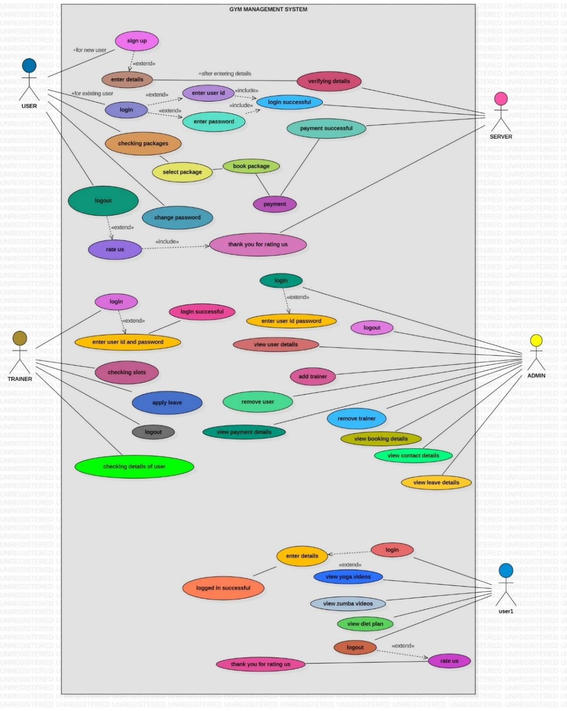

* + 1. **CLASS DIAGRAM**

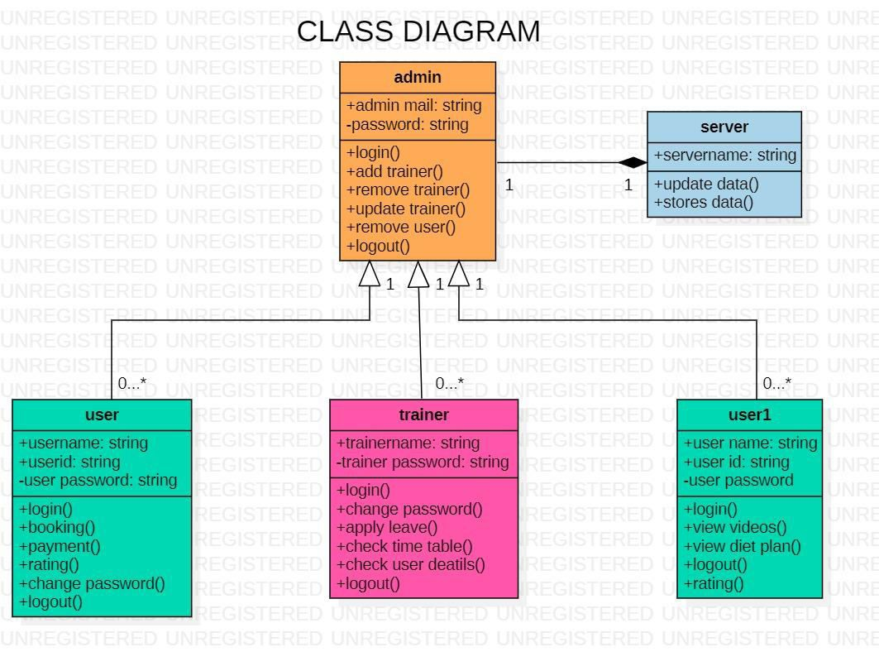

* + 1. **ACTIVITY DIAGRAM**

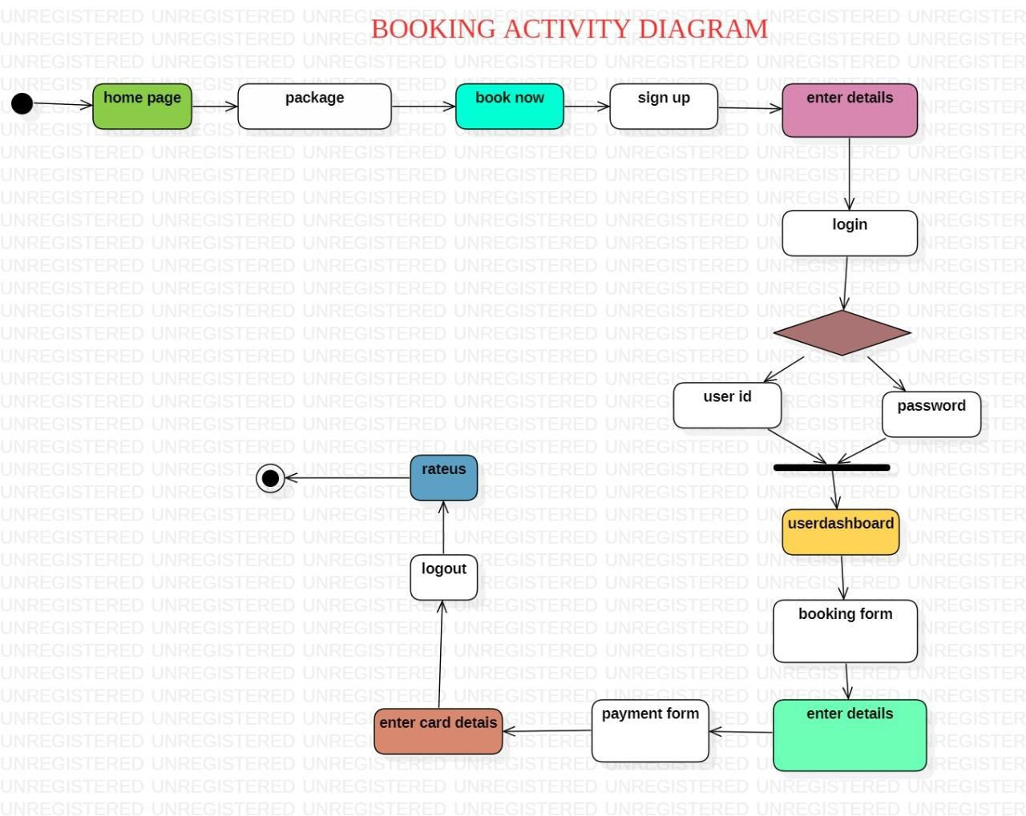

# CHAPTER 4 IMPLEMENTATION AND RESULT

## CHAPTER – 4 IMPLEMENTATION AND RESULT

### CODING DETAILS

#### Main.html

<html>

<head>

<title> Gym </title>

<link rel="stylesheet" href="mainstyle.css">

<link rel="stylesheet" href="https://cdnjs.cloudflare.com/ajax/libs/animate.css/3.7.2/animate.min.css">

</head>

<body>

<header>

<nav>

<div class="logo">

<h1 class="animated infinite heartBeat"><font color="#FFF0F5"> SOLID BODY </font> </h1>

</div>

<div class="menu">

<a href="about.html"> About </a>

<a href="gallary.html"> Gallery </a>

<a href="package.html"> Packages </a>

<a href="loginboard.html"> Log in </a>

<a href="contact.html"> Contact </a>

</div>

</nav>

<main>

<section>

<font color="#E6E6FA">

<h3><b> The only body that is </b></h3>

<h2> perfect motivation for you </h2>

<p><b> is your own ! </b></p></font>

<a href="signupform.html" class="one"> Sign up </a>

<a href="learnmore.html" class="two"> Learn more </a>

</section>

</main>

<div class="footer">

<marquee> For any queries: [solidbody@gmail.com](mailto:solidbody@gmail.com) &nbsp;&nbsp; OR &nbsp;&nbsp; Call us on 7726882506 / 9963348475 </marquee>

</div>

</header>

</body>

</html>

#### About.html

<html>

<head>

<title> Gym </title>

<link rel="stylesheet" href="aboutstyle.css">

<link rel="stylesheet" href="https://cdnjs.cloudflare.com/ajax/libs/animate.css/3.7.2/animate.min.css">

<link rel="stylesheet" href="https://stackpath.bootstrapcdn.com/font- awesome/4.7.0/css/font-awesome.min.css">

<link href="[https://cdn.jsdelivr.net/npm/@fortawesome/fontawesome-](https://cdn.jsdelivr.net/npm/%40fortawesome/fontawesome-) free@5.15.4/css/fontawesome.min.css">

</head>

<body>

<section class="sub-header">

<nav>

<div class="logo">

<h1 class="animated infinite heartBeat"><font color="#FFF0F5"> SOLID BODY </font> </h1>

</div>

<div class="menu">

<a href="about.html"> About </a>

<a href="gallary.html"> Gallery </a>

<a href="package.html"> Packages </a>

<a href="loginboard.html"> Log in </a>

<a href="contact.html"> Contact </a>

</div>

</nav>

<h1><b>About Us</h1></b>

</section>

<section class="About-Us">

<div class="row">

<div class="about-col">

<h2>Health, Wellness and Fitness</h2>

<p1><b>&#8594;<u>solidbody.co.in</b></u> is a platform that brings together trainers and coaches forming a community to provide affordable, professional and result oriented output for our customers with the comfort of personalized specialist programs. Through this platform let us explore why wellness deserves special attention and practice. </p1>

<ul type="square">

<b><li> GROUP FITNESS </li></b>

<b><li> WORKPLACE ASSESSMENTS </li></b>

<b><li> WORK-LIFE WORKSHOP </li></b>

<b><li> MASSAGE THERAPY </li></b>

<br>

<p2><b><u>Other Programs include:</b></u></p2>

<ol>

<li>Football is one of the most popular game in the world. Participating in football -like any other sport- provides many health benefits for children. That is where the role of coach is vita.India has lacked skilled coaches at the grassroots level, who can work towards identification of talent and guide them in the right direction that provides an opportunity for childrens to improve their speed, agility strength, hand-eye coordination and over all cardiovascular endurance.</li>

<li>Boxing often called "the mainly art of self defence" in youth it is more popular but boxing may not be the first choice of parents but surprisingly boxing can teach kids a lot of valuable virtues, including sportsmanship, resilience and hardworking. In fact, boxing can be advantageous for all genders So, what is the best way to teach your child boxing.</li>

</ol>

</ul>

</div>

<dic class="pic"><img src="harshita.jpeg" height=300 width=300 border=2>

<div class="layer">

<h3>HARSHITA[FOUNDER]</h3>

</div>

</div>

<div class="pic"><img src="sai.jpg" height=300 width=300 border=2>

<div class="layer">

<h3>PRATHYUSHA[CO-FOUNDER]</h3>

</div>

</div>

</section>

<section class="footer">

<h2>About Us</h2>

<h3>‘’Health, Wellness and Fitness”.</h3>

<p><b>solidbody.co.in</b> is a platform that brings together trainers and coaches forming a community to provide affordable, professional and result oriented output for our customers with the comfort of personalized specialist programs. Through this platform let us explore why wellness deserves special attention and practice.</p>

<div class="icons">

<i class="fa fa-facebook"></i>

<i class="fa fa-twitter"></i>

<i class="fa fa-instagram"></i>

<i class="fa fa-linkedin"></i>

<i class="fa fa-youtube"></i>

</div>

</section>

</body>

</html>

#### Gallery.html

<html>

<head>

<title> Gallery </title>

<link rel="stylesheet" href="https://cdnjs.cloudflare.com/ajax/libs/animate.css/3.7.2/animate.min.css">

</head>

<body background="bg.jpg">

<header>

<nav>

<div class="logo">

<h1 class="animated infinite heartBeat"><font color="#FFF0F5"> SOLID BODY </font> </h1>

</div>

<div class="menu">

<a href="about.html"> About </a>

<a href="gallary.html"> Gallery </a>

<a href="package.html"> Packages </a>

<a href="loginboard.html"> Log in </a>

<a href="contact.html"> Contact </a>

</div>

</nav>

<video width="800" height="500" autoplay controls loop>

<source src="gymvideo.mp4" type="video/mp4">

</video>

<h1><font color="white"> EQUIPMENTS </font></h1>

</header>

<hr/>

<main>

<div class="pic"><img src="1.png"> <div class="des"> Squat Rack </div></div>

<div class="pic"><img src="2.png"> <div class="des"> Bench Press </div></div>

<div class="pic"><img src="3.png"> <div class="des"> Incline Bench Press </div></div>

<div class="pic"><img src="4.png"> <div class="des"> Strength Machine </div></div>

<div class="pic"><img src="5.png"> <div class="des"> Cables & Pulleys </div></div>

<div class="pic"><img src="6.png"> <div class="des"> Dumbbells </div></div>

<div class="pic"><img src="7.png"> <div class="des"> Leg Extension </div></div>

<div class="pic"><img src="8.png"> <div class="des"> Lat Pulldown </div></div>

<div class="pic"><img src="9.png"> <div class="des"> Leg Curl Machine </div></div>

<div class="pic"><img src="10.png"> <div class="des"> Smith Machine </div></div>

<div class="pic"><img src="11.png"> <div class="des"> Preacher Bench </div></div>

<div class="pic"><img src="12.png"> <div class="des"> Abdominal Bench </div></div>

<div class="pic"><img src="13.png"> <div class="des"> Leg Press Machine </div></div>

<div class="pic"><img src="14.png"> <div class="des"> Calf Machine </div></div>

<div class="pic"><img src="15.png"> <div class="des"> Indoor Cycle Bike </div></div>

<div class="pic"><img src="16.png"> <div class="des"> Kettle Bells </div></div>

<div class="pic"><img src="17.jpg"> <div class="des"> Treadmill </div></div>

<div class="pic"><img src="18.png"> <div class="des"> Peck Deck Machine </div></div>

</main>

<h1 align="center"><font color="white"> TRAINERS </font></h1>

<hr/>

<main>

<div class="pics"><img src="trainer1.jpg" height=300><div class="des"> VARUN <br> State champion <br> (Body building)

</div>

</div>

<div class="pics"><img src="trainer2.jpg" height=300><div class="des"> KARAN <br> State Runner up <br> (Weight Lifting)

</div>

</div>

<div class="pics"><img src="trainer3.jpg" height=300><div class="des"> KAIRA <br> Best Body

<br> (Female)

</div>

</div>

<div class="pics"><img src="trainer4.jpg" height=300><div class="des"> ARHAAN <br> Mr. Telangana <br> (Power Lifting)

</div>

</div>

</main>

</body>

</html>

#### Package.html

<html>

<head>

<title> Packages </title>

</head>

<body>

<header>

<nav>

<div class="logo">

<h1 class="animated infinite heartBeat"><font color="#FFF0F5"> SOLID BODY </font> </h1>

</div>

<div class="menu">

<a href="about.html"> About </a>

<a href="gallary.html"> Gallery </a>

<a href="package.html"> Packages </a>

<a href="loginboard.html"> Log in </a>

<a href="contact.html"> Contact </a>

</div>

</nav>

<h1 align="center"><font color="white"> PACKAGES </font></h1>

<div class="box-container">

<div class="box">

<div class="text">

<h3><a href="gymmembership.html"> Gym Membership </a></h3>

<p> Rs 5000 <br>(For 1 Year) </p>

</div>

</div>

<div class="box">

<div class="text">

<h3><a href="24hraccess.html"> The 24 hour access gym </a></h3>

<p> Rs 4000 <br>(For 6 Months) </p>

</div>

</div>

<div class="box">

<div class="text">

<h3><a href="crossfit.html"> CrossFit </a></h3>

<p> Rs 3000 <br>(For 6 Months) </p>

</div>

</div>

<div class="box">

<div class="text">

<h3><a href="boxing.html"> Boxing </a></h3>

<p> Rs 3000 <br>(For 6 Months) </p>

</div>

</div>

<div class="box">

<div class="text">

<h3><a href="weightlifting.html"> Weight Lifting </a></h3>

<p> Rs 3000 <br>(For 6 Months) </p>

</div>

</div>

<div class="box">

<div class="text">

<h3><a href="womensgym.html"> Womens gym </a></h3>

<p> Rs 3000 <br>(For 6 Months) </p>

</div>

</div>

</div>

<div class="box-containers">

<div class="boxs">

<div class="text">

<h3><a href="powerlifting.html"> Powerlifting </a></h3>

<p> Rs 4000 <br>(For 6 Months) </p>

</div>

<div class="boxs">

<div class="text">

<h3><a href="cardio.html"> Cardio Fitness </a></h3>

<p> Rs 4000 <br>(For 6 Months) </p>

</div>

</div>

<div class="boxs">

<div class="text">

<h3><a href="strengthtraining.html"> Strength Training </a></h3>

<p> Rs 3000 <br>(For 6 Months) </p>

</div>

</div>

<div class="boxs">

<div class="text">

<h3><a href="hardcore.html"> Hardcore Exercises </a></h3>

<p> Rs 3500 <br>(For 6 Months) </p>

</div>

</div>

<div class="boxs">

<div class="text">

<h3><a href="weightlose.html"> Weight Losing Exercises </a></h3>

<p> Rs 3000 <br>(For 6 Months) </p>

</div>

</div>

<div class="boxs">

<div class="text">

<h3><a href="bodybuilding.html"> Bodybuilding </a></h3>

<p> Rs 4500 <br>(For 6 Months) </p>

</div>

</div>

</header>

</body>

</html>

#### Contact.html

<html>

<head>

<title> Gym </title>

<link rel="stylesheet" href="contactstyle.css">

<link rel="stylesheet" href="https://cdnjs.cloudflare.com/ajax/libs/animate.css/3.7.2/animate.min.css">

<link rel="stylesheet" href="https://stackpath.bootstrapcdn.com/font- awesome/4.7.0/css/font-awesome.min.css">

<link href="[https://cdn.jsdelivr.net/npm/@fortawesome/fontawesome-](https://cdn.jsdelivr.net/npm/%40fortawesome/fontawesome-) free@5.15.4/css/fontawesome.min.css">

</head>

<body>

<section class="sub-header">

<nav>

<div class="logo">

<h1 class="animated infinite heartBeat"><font color="#FFF0F5"> SOLID BODY </font> </h1>

</div>

<div class="menu">

<a href="about.html"> About </a>

<a href="gallary.html"> Gallery </a>

<a href="package.html"> Packages </a>

<a href="loginboard.html"> Log in </a>

<a href="contact.html"> Contact </a>

</div>

</nav>

<h1><b>Contact Us</b></h1>

</section>

<section class="location">

<iframe src="https://[www.google.com/maps/embed?pb=!1m18!1m12!1m3!1d7604.787753757759!2d78.4863](http://www.google.com/maps/embed?pb=!1m18!1m12!1m3!1d7604.787753757759!2d78.4863) 607!3d17.63149449999999!2m3!1f0!2f0!3f0!3m2!1i1024!2i768!4f13.1!3m3!1m2!1s0x3bcb861a3d5

f52cd%3A0x3c0bc47eb187dfdf!2sMedchal%2C%20Secunderabad%2C%20Telangana%20501401!5 e0!3m2!1sen!2sin!4v1642480415494!5m2!1sen!2sin" width="600" height="450" style="border:0;" allowfullscreen="" loading="lazy"></iframe>

</section>

<section class="contact-us">

<div class="row">

<div class="contact-col">

<div>

<i class="fa fa-home"></i>

<span>

<h5>Rukmini Knowledge Park, Kattigenahalli Yelahanka</h5>

<p>Medchal,Hyderabad, IN</p>

</span>

</div>

<div>

<i class="fa fa-phone"></i>

<span>

<h5>080-46966966</h5>

<p>Medchal,Hyderabad, IN</p>

</span>

</div>

<div>

<i class="fa fa-envelope-o"></i>

<span>

<h5>solidbody.co.in</h5>

<p>Email us your query</p>

</span>

</div>

</div>

<div class="contact-col">

<form action="contact.php" method="get">

<input type="text" name="t1" placeholder="Enter Your Name" required>

<input type="email" name="t2" placeholder="Enter Email Address" required>

<input type="text" name="t3" placeholder="Enter Your Subject" required>

<textarea rows="8" name="t4" placeholder="Message" required></textarea><br>

<button type="submit" class="red-btn"> SEND MESSAGE </button>

</form>

</div>

</div>

</section>

<section class="footer">

<h2>About Us</h2>

<h3>‘’Health, Wellness and Fitness”.</h3>

<p><b>solidbody.co.in</b> is a platform that brings together trainers and coaches forming a community to provide affordable, professional and result oriented output for our customers with the comfort of personalized specialist programs. Through this platform let us explore why wellness deserves special attention and practice.</p>

<div class="icons">

<i class="fa fa-facebook"></i>

<i class="fa fa-twitter"></i>

<i class="fa fa-instagram"></i>

<i class="fa fa-linkedin"></i>

<i class="fa fa-youtube"></i>

</div>

</section>

</body>

</html>

#### Contact.php

<?php

$servername = "localhost";

$username = "root";

$password = "";

$dbname = "Project"; try

{

$conn = new PDO("mysql:host=$servername;dbname=$dbname", $username, $password);

$name = $_GET['t1'];

$email = $_GET['t2'];

$subject = $_GET['t3'];

$message = $_GET['t4']; if(empty($name))

{

echo '<script type="text/javascript"> window.alert("Name is required. ")</script>';

}

if(empty($email))

{

echo '<script type="text/javascript"> window.alert("Email id is required ")</script>';

}

if(empty($subject))

{

echo '<script type="text/javascript"> window.alert("Subject is required ")</script>';

}

if(empty($message))

{

echo '<script type="text/javascript"> window.alert("Message is required. ")</script>';

}

$sql = "INSERT INTO contact (name,email,subject,message) VALUES ('$name','$email','$subject','$message')";

$i=$conn->exec($sql); if($i>0)

{

echo '<script type="text/javascript"> window.alert("Message sent successfully !")</script>';

}

else

{

}

}

echo "<script>location.replace('contact.html')</script>";

echo "Duplicate or invalid data";

catch(PDOException $e)

{

echo $sql . "<br>" . $e->getMessage();

}

$conn = null;

?>

#### Signup.html

<html>

<head>

<title> Sign up form </title>

<link rel="stylesheet" href="https://cdnjs.cloudflare.com/ajax/libs/animate.css/3.7.2/animate.min.css">

</head>

<body>

<header>

<nav>

<div class="logo">

<h1 class="animated infinite heartBeat"><font color="#FFF0F5"> SOLID BODY </font> </h1>

</div>

<div class="menu">

<a href="about.html"> About </a>

<a href="gallary.html"> Gallery </a>

<a href="package.html"> Packages </a>

<a href="loginform.html"> Log in </a>

<a href="contact.html"> Contact </a>

</div>

</nav>

<div class="sign">

<img src="user.png">

<h1> Create Account </h1>

<form action="signupform.php" method="get">

<input name="t1" type="email" class="input" placeholder="Email:">

<input name="t2" type="text" class="input" placeholder="User name:">

<input name="t3" type="password" class="input" placeholder="New Password:">

<p><span><input type="checkbox"></span>

<font color="white"> I agree terms & conditions </font></p>

<button type="submit" class="btn1"> Sign up </button>

<p><font color="white"> Already have an account? </font><a href="loginform.html"><font color="red"> Sign in </font></a> </p>

</form>

</div>

</header>

</body>

</html>

#### Signupform.php

<?php

$servername = "localhost";

$username = "root";

$password = "";

$dbname = "Project"; try

{

$conn = new PDO("mysql:host=$servername;dbname=$dbname", $username, $password);

$email = $_GET['t1'];

$username = $_GET['t2'];

$password = $_GET['t3']; if(empty($email))

{

echo '<script type="text/javascript"> window.alert("Email id is required ")</script>';

}

if(empty($username))

{

echo '<script type="text/javascript"> window.alert("Username is required. ")</script>';

}

if(empty($password))

{

echo '<script type="text/javascript"> window.alert("Password is required. ")</script>';

}

$sql = "INSERT INTO signup (email,username,password) VALUES ('$email','$username','$password')";

$i=$conn->exec($sql); if($i>0)

{

echo '<script type="text/javascript"> window.alert("YOU have successfully registered..... sign in to continue")</script>';

echo "<script>location.replace('loginform.html')</script>";

}

else

{

}

}

echo "Duplicate or invalid data";

catch(PDOException $e)

{

echo $sql . "<br>" . $e->getMessage();

}

$conn = null;

?>

#### Loginform.html

<html>

<head>

<title> Log in form </title>

<link rel="stylesheet" href="https://cdnjs.cloudflare.com/ajax/libs/animate.css/3.7.2/animate.min.css">

</head>

<body>

<header>

<nav>

<div class="logo">

<h1 class="animated infinite heartBeat"><font color="#FFF0F5"> SOLID BODY </font> </h1>

</div>

<div class="menu">

<a href="about.html"> About </a>

<a href="gallary.html"> Gallery </a>

<a href="package.html"> Packages </a>

<a href="loginform.html"> Log in </a>

<a href="contact.html"> Contact </a>

</div>

</nav>

<div class="sign">

<img src="user.png">

<h1> Hello User </h1>

<form action="loginform.php" name='u1' method="POST">

<input type="text" class="input" name="user" placeholder="Username:">

<input type="password" class="input" name="pass" placeholder="Password:">

<a href="#">

<font color="white"> Forget password? </font></a>

<button type="submit" class="btn1"> Log In </button>

</form>

</div>

</header>

</body>

</html>

#### Loginform.php

<?php session_start();

$servername = "localhost";

$username = "root";

$password = "";

$dbname = "Project"; try

{

$conn = new PDO("mysql:host=$servername;dbname=$dbname", $username, $password);

$username = $_POST['user'];

$password = $_POST['pass'];

$sql = "select * from signup where username='$username' and password='$password'";

$data = $conn->query($sql);

$cnt=0;

foreach($data as $row)

$cnt=$cnt+1; if ($cnt>0 )

{

$uid=$row['username']; session_start();

$_SESSION['username']=$uid; header('location:userdashboard.html');

}

else{

echo '<script type="text/javascript"> window.alert("Incorrect username/password. try

again!!")</script>';

echo "<script>location.replace('login.html')</script>";

//header('Location: login.html');

}

}

catch(PDOException $e)

{

echo"<br>"."<br>".$e->getMessage();

}

?>

#### Userdashboard.html

<html>

<head>

<title> User Dashboard </title>

</head>

<body>

<header>

<nav>

<div class="logo">

<h1 class="animated infinite heartBeat"><font color="#FFF0F5"> SOLID BODY </font> </h1>

</div>

<div class="menu">

<a href="rate.html"> Logout </a>

</div>

</nav>

<div class="sidebar">

<center>

<img src="user.png" class="profile" alt="">

<div class="text"> <h4><a href="passworduser.html"><font color="white"> Change password

</font></a></h4><div>

</center>

</div>

<br><br><br>

<div class="box-container">

<div class="box1">

<div class="text">

<h2><a href="bookingform.html"><br> Package Booking </a></h2>

</div>

</div>

<div class="box2">

<div class="text">

<h2><a href="yogavideos.html"><br> Join Online Yoga <br> Session </a></h2>

</div>

</div>

</div>

<div class="box-containers">

<div class="boxs1">

<div class="text">

<h2><a href="zumbavideos.html"><br> Join Online Zumba <br> Session </a></h2>

</div>

</div>

<div class="boxs2">

<div class="text">

<h2><a href="diet.html"><br> Diet Plan </a></h2>

</div>

</div>

</div>

</header>

</body>

</html>

#### Bookingform.html

<html>

<head>

<title> Booking form </title>

</head>

<body>

<header>

<nav>

<div class="logo">

<h1><a href="userdashboard.html"><font color="#FFF0F5"> Back </font> </a></h1>

</div>

</nav>

</header>

<form action="bookingform.php" method="get">

<h2 align="center">BOOKING DETAILS </h2>

<table class="table" height="400" width="600" border="3" cell padding="6" align="center">

<tr><td> &nbsp Name:

</td>

<td>

<input type="text" name="t1">

</td></tr>

<tr><td> &nbsp Gender:

</td>

<td>

&nbsp Male <input type="radio" name="r1" value="Male"> Female <input type="radio" name="r1" value="Female">

</td></tr>

<tr><td> &nbsp Age:

</td>

<td>

<input type="text" name="t2">

</td></tr>

<tr><td>

&nbsp Email id:

</td>

<td>

<input type="text" name="t3">

</td></tr>

<tr><td>

&nbsp Phone No:

</td>

<td>

<input type="text" name="t4">

</td></tr>

<tr><td> &nbsp Package:

</td>

<td>

<select name="s1" id="Package">

<option> Gym Membership </option>

<option> Crossfit </option>

<option> Boxing </option>

<option> Weight Lifting </option>

<option> Womens Gym </option>

<option> Powerlifting </option>

<option> Cardio Fitness </option>

<option> Strength Training </option>

<option> Hardcore Exercises </option>

<option> Weight Losing exercise </option>

<option> Bodybuilding </option>

</select>

</td></tr>

<tr><td>

&nbsp Time slot:

</td>

<td>

<select name="s2" id="Time">

<option> 6:00 AM-8:00 AM </option>

<option> 8:00 AM-10:00 AM </option>

<option> 10:00 AM-12:00 PM </option>

<option> 4:00 PM-6:00 PM </option>

<option> 6:00 PM-8:00 PM </option>

</select>

</td></tr>

<tr><td>

&nbsp Personal Trainer: &nbsp

</td>

<td>

&nbsp With <input type="radio" name="r2" value="With"> Without <input type="radio" name="r2" value="Without">

</td></tr>

<tr><td> &nbsp Address:

</td>

<td>

<textarea rows="4" cols="50" name="t5">

</textarea>

</td></tr>

</table>

<h2 align="center">

<button type="submit" class="btn1"> Proceed for payment </button>

</h2>

</form>

</body>

</html>

#### Bookingform.php

<?php

$servername = "localhost";

$username = "root";

$password = "";

$dbname = "Project"; try

{

$conn = new PDO("mysql:host=$servername;dbname=$dbname", $username, $password);

$name = $_GET['t1'];

$gender = $_GET['r1'];

$age = $_GET['t2'];

$emailid = $_GET['t3'];

$phnno = $_GET['t4'];

$package = $_GET['s1'];

$slot = $_GET['s2'];

$trainer = $_GET['r2'];

$address = $_GET['t5']; if(empty($name))

{

echo '<script type="text/javascript"> window.alert("Name is required. ")</script>';

}

if(empty($gender))

{

echo '<script type="text/javascript"> window.alert("Gender is required. ")</script>';

}

if(empty($age))

{

echo '<script type="text/javascript"> window.alert("Age is required. ")</script>';

}

if(empty($emailid))

{

echo '<script type="text/javascript"> window.alert("Email id is required ")</script>';

}

if(empty($phnno))

{

echo '<script type="text/javascript"> window.alert("Phone no. is required. ")</script>';

}

if(empty($package))

{

echo '<script type="text/javascript"> window.alert("Package is required. ")</script>';

}

if(empty($slot))

{

echo '<script type="text/javascript"> window.alert("Time slot is required. ")</script>';

}

if(empty($trainer))

{

echo '<script type="text/javascript"> window.alert("Trainer is required. ")</script>';

}

if(empty($address))

{

echo '<script type="text/javascript"> window.alert("Address is required. ")</script>';

}

$sql = "INSERT INTO booking (name,gender,age,emailid,phnno,package,slot,trainer,address) VALUES ('$name','$gender','$age','$emailid','$phnno','$package','$slot','$trainer','$address')";

$i=$conn->exec($sql); if($i>0)

{

echo "<script>location.replace('payment.html')</script>";

}

else

{

}

}

echo "Duplicate or invalid data";

catch(PDOException $e)

{

echo $sql . "<br>" . $e->getMessage();

}

$conn = null;

?>

#### payment.html

<html>

<head>

<title>Payment Form</title>

<link rel="stylesheet" href="paymentstyle.css">

<link rel="preconnect" href="https://fonts.googleapis.com">

<link rel="preconnect" href="https://fonts.gstatic.com" crossorigin>

<link href="[https://fonts.googleapis.com/css2?family=Poppins:wght@400;500;600;700&display=swap"](https://fonts.googleapis.com/css2?family=Poppins%3Awght%40400%3B500%3B600%3B700&display=swap) rel="stylesheet">

</head>

<body>

<form action="payment.php" method="get">

<div class="container">

<h1>Payment Details</h1>

<div class="first-row">

<div class="owner">

<h3>Owner</h3>

<div class="input-field">

<input type="text" name="t1">

</div></div>

<div class="cvv">

<h3>CVV</h3>

<div class="input-field">

<input type="password" name="t2">

</div></div>

</div>

<div class="second-row">

<div class="card-number">

<h3>Card Number</h3>

<div class="input-field">

<input type="text" name="t3">

</div></div>

</div>

<div class="third-row">

<h3>Card validity</h3>

<div class="selection">

<div class="date">

<select name="s1" id="months">

<option value="Jan">Jan</option>

<option value="Feb">Feb</option>

<option value="Mar">Mar</option>

<option value="Apr">Apr</option>

<option value="May">May</option>

<option value="Jun">Jun</option>

<option value="Jul">Jul</option>

<option value="Aug">Aug</option>

<option value="Sep">Sep</option>

<option value="Oct">Oct</option>

<option value="Nov">Nov</option>

<option value="Dec">Dec</option>

</select>

<select name="s2" id="years">

<option value="2021">2022</option>

<option value="2020">2023</option>

<option value="2019">2024</option>

<option value="2018">2025</option>

<option value="2017">2026</option>

<option value="2016">2027</option>

<option value="2015">2028</option>

</select>

</div>

<div class="cards">

<img src="mc.png" alt="">

<img src="visa.png" alt="">

<img src="pp.png" alt="">

</div></div>

</div>

<button type="submit" class="btn1">PAY </button>

</div></div>

</form>

</body>

</html>

#### payment.php

<?php

$servername = "localhost";

$username = "root";

$password = "";

$dbname = "Project"; try

{

$conn = new PDO("mysql:host=$servername;dbname=$dbname", $username, $password);

$owner = $_GET['t1'];

$cvv = $_GET['t2'];

$cardnumber = $_GET['t3'];

$validitym = $_GET['s1'];

$validityy = $_GET['s2']; if(empty($owner))

{

echo '<script type="text/javascript"> window.alert("Name is required. ")</script>';

}

if(empty($cvv))

{

echo '<script type="text/javascript"> window.alert("CVV is required. ")</script>';

}

if(empty($cardnumber))

{

echo '<script type="text/javascript"> window.alert("Card Number is required. ")</script>';

}

if(empty($validitym))

{

echo '<script type="text/javascript"> window.alert("Validity month is required. ")</script>';

}

if(empty($validityy))

{

echo '<script type="text/javascript"> window.alert("Validity year is required. ")</script>';

}

$sql = "INSERT INTO Payment (owner,cvv,cardnumber,validitym,validityy) VALUES ('$owner','$cvv','$cardnumber','$validitym','$validityy')";

$i=$conn->exec($sql); if($i>0)

{

echo '<script type="text/javascript"> window.alert("Payment successfull !

You can join your course from today istself.")</script>';

echo "<script>location.replace('userdashboard.html')</script>";

}

else

{

echo "Duplicate or invalid data";

}

}

catch(PDOException $e)

{

echo $sql . "<br>" . $e->getMessage();

}

$conn = null;

#### Yogavideos.html

<html>

<head>

<title>Video</title>

<link rel="stylesheet" href="https://stackpath.bootstrapcdn.com/font- awesome/4.7.0/css/font-awesome.min.css">

<link href="[https://cdn.jsdelivr.net/npm/@fortawesome/fontawesome-](https://cdn.jsdelivr.net/npm/%40fortawesome/fontawesome-) free@5.15.4/css/fontawesome.min.css">

</head>

<body bgcolor="#92a8d1">

<nav>

<div class="logo">

<h1><a href="userdashboard.html"> <font color="#FFF0F5"> BACK </font> </a></h1>

</div>

</nav>

<marquee height="60" width="100%" behavior="scroll" ><h1><u><font color="purple">YOGA VIDEOS</font></u></h1></marquee>

<video width="650" height="500" autoplay controls loop>

<source src="yoga-1.mp4" type="video/mp4">

</video>

<video width="655" height="500" autoplay controls loop>

<source src="yoga-2.mp4" type="video/mp4">

</video><br>

<video width="655" height="500" autoplay controls loop>

<source src="yoga-3.mp4" type="video/mp4">

</video>

<video width="655" height="500" autoplay controls loop>

<source src="yoga-4.mp4" type="video/mp4">

</video>

<video width="655" height="500" autoplay controls loop>

<source src="yoga-5.mp4" type="video/mp4">

</video>

<video width="655" height="500" autoplay controls loop>

<source src="yoga-6.mp4" type="video/mp4">

</video>

<br><br><br><br><br>

<div class="content">

<h1 align="center"><b>YOGA</b></h1>

<p>&nbsp;&nbsp;&nbsp;Yoga is essentially a spiritual discipline based on an extremely subtle &nbsp;&nbsp;&nbsp;science, which focuses on bringing

harmony between mind and body. &nbsp;&nbsp;&nbsp;It is an art and scince of healthy living. The word Yoga is derived from &nbsp;&nbsp;&nbsp;the

Sanskrit root Yuj, meaning to join or to yoke or to unite.It is a &nbsp;&nbsp;&nbsp;system- a holistic system of refining the body, the mind and

the spirit &nbsp;&nbsp;&nbsp;in unison. Ultimately, it is well-being, peace and bliss. Yogic postures &nbsp;&nbsp;&nbsp;help strengthen the

endocrine system and also bring the emotions &nbsp;&nbsp;&nbsp;under control through concentration and relaxation.</p>

<br><br><br><h1 align="center"><b>DO'S</b></h1>

&nbsp;&nbsp;&nbsp;1.Early to bed and early to rise makes man healthy, wealthy and &nbsp;&nbsp;&nbsp;&nbsp;&nbsp;&nbsp;&nbsp;&nbsp;wise, is an universal adage.

<br>&nbsp;&nbsp;&nbsp;2.One could practice it before bath but after practice one should wait &nbsp;&nbsp;&nbsp;&nbsp;&nbsp;&nbsp;for some time and then take a bath.

<br>&nbsp;&nbsp;&nbsp;3.It should be practiced on a leveled floor in a room where doors and &nbsp;&nbsp;&nbsp;&nbsp;&nbsp;&nbsp;windows are kept open for air and light.

<br><br><br><br><br>

<h1 align="center"><b>DONT'S</b></h1>

&nbsp;&nbsp;&nbsp;1.One should not practice it directly on the ground, on cement or mortar &nbsp;&nbsp;&nbsp;&nbsp;&nbsp;&nbsp;floor. Instead, spread a carpet, a blanket or a clean cloth,

sit on it and &nbsp;&nbsp;&nbsp;&nbsp;&nbsp;&nbsp;practice by facing east or north in the morning, west or south in the &nbsp;&nbsp;&nbsp;&nbsp;&nbsp;&nbsp;evening.

<br>&nbsp;&nbsp;&nbsp;2.Yoga should not be practiced in stormy winds either

<br>&nbsp;&nbsp;&nbsp;3.One should avoid practice in unclean/smoky places and in areas with &nbsp;&nbsp;&nbsp;&nbsp;&nbsp;&nbsp;foul smell

<br><br><br><br><br>

<h1 align="center">Benefits of Yoga</h1>

<b>&nbsp;&nbsp;&nbsp;1.Yoga improves strength, balance and flexibility.</b>

<p><b>&nbsp;&nbsp;&nbsp;Try it: </b>Tree Pose

Balance on one foot, while holding the other foot to &nbsp;&nbsp;&nbsp;&nbsp;&nbsp;&nbsp;your calf or above the knee (but never on the knee) at a right angle. &nbsp;&nbsp;&nbsp;&nbsp;&nbsp;&nbsp;Try to focus on one spot in front of you, while you balance for one &nbsp;&nbsp;&nbsp;&nbsp;&nbsp;&nbsp;minute. </p>

<b>&nbsp;&nbsp;&nbsp;2.Yoga helps with back pain relief.</b>

<p><b>&nbsp;&nbsp;&nbsp;Try it:</b> Cat-Cow Pose

Get on all fours, placing your palms underneath &nbsp;&nbsp;&nbsp;&nbsp;&nbsp;&nbsp;your shoulders and your knees underneath your hips. First, inhale, as &nbsp;&nbsp;&nbsp;&nbsp;&nbsp;&nbsp;you let your stomach drop down toward the floor. Then, exhale, as &nbsp;&nbsp;&nbsp;&nbsp;&nbsp;&nbsp;you draw your navel toward your spine, arching your spine like a cat &nbsp;&nbsp;&nbsp;&nbsp;&nbsp;&nbsp;stretching. </p>

<b>&nbsp;&nbsp;&nbsp;3.Yoga can ease arthritis symptoms.</b>

<p>&nbsp;&nbsp;&nbsp;Gentle yoga has been shown to ease some of the discomfort of tender, &nbsp;&nbsp;&nbsp;&nbsp;swollen joints for people with arthritis</p>

<b>&nbsp;&nbsp;&nbsp;4.Yoga benefits heart health.</b>

<p><b>&nbsp;&nbsp;&nbsp;Try it:</b> Downward Dog Pose

Get on all fours, then tuck your toes under &nbsp;&nbsp;&nbsp;&nbsp;&nbsp;&nbsp;and bring your sitting bones up, so that you make a triangle shape. &nbsp;&nbsp;&nbsp;&nbsp;&nbsp;&nbsp;Keep a slight bend in your knees, while lengthening your spine and &nbsp;&nbsp;&nbsp;&nbsp;&nbsp;&nbsp;tailbone.</p>

<b>&nbsp;&nbsp;&nbsp;5.Yoga relaxes you, to help you sleep better.</b>

<p><b>&nbsp;&nbsp;&nbsp;Try It: </b>Legs-Up-the-Wall Pose

Sit with your left side against a wall, &nbsp;&nbsp;&nbsp;&nbsp;&nbsp;&nbsp;then gently turn right and lift your legs up to rest against the wall, &nbsp;&nbsp;&nbsp;&nbsp;&nbsp;&nbsp;keeping your back on the floor and your sitting bones close to the &nbsp;&nbsp;&nbsp;&nbsp;&nbsp;&nbsp;wall. You can remain in this position for 5 to 15 minutes.

</p>

<b>&nbsp;&nbsp;&nbsp;6.Yoga can mean more energy and brighter moods.</b>

<p>&nbsp;&nbsp;&nbsp;You may feel increased mental and physical energy, a boost in alertness &nbsp;&nbsp;&nbsp;&nbsp;&nbsp;&nbsp;and enthusiasm, and fewer negative feelings after getting into a &nbsp;&nbsp;&nbsp;&nbsp;&nbsp;&nbsp;routine of practicing yoga.</p>

<b>&nbsp;&nbsp;&nbsp;7.Yoga helps you manage stress. </b>

<p><b>&nbsp;&nbsp;&nbsp;Try It:</b> Corpse Pose (Savasana)

Lie down with your limbs gently &nbsp;&nbsp;&nbsp;&nbsp;&nbsp;&nbsp;stretched out, away from the body, with your palms facing up. Try to &nbsp;&nbsp;&nbsp;&nbsp;&nbsp;&nbsp;clear your mind while breathing deeply. You can hold this pose for 5 &nbsp;&nbsp;&nbsp;&nbsp;&nbsp;&nbsp;to 15 minutes.</p>

<b>&nbsp;&nbsp;&nbsp;8.Yoga connects you with a supportive community.</b>

<p>&nbsp;&nbsp;&nbsp;&nbsp;&nbsp;&nbsp;Participating in yoga classes can ease loneliness and provide an &nbsp;&nbsp;&nbsp;&nbsp;&nbsp;&nbsp;environment for group healing and support. Even during one-on-one &nbsp;&nbsp;&nbsp;&nbsp;&nbsp;&nbsp;sessions loneliness is reduced as one is acknowledged as a unique &nbsp;&nbsp;&nbsp;&nbsp;&nbsp;&nbsp;individual, being listened to and participating in the creation of a &nbsp;&nbsp;&nbsp;&nbsp;&nbsp;&nbsp;personalized yoga plan.</p>

<br><br><br><br><br>

<h1 align="center"><b>Types of yoga</b></h1>

<h3 align="center"><b>Pranayama</b><br></h3>

<h3 align="center"><b>Kriyas</b><br></h3>

<h3 align="center"><b>Meditation</b><br></h3>

<h3 align="center"><b>Raja Yoga</b><br></h3>

<h3 align="center"><b>Bhakti Yoga</b><br></h3>

<h3 align="center"><b>Karma Yoga</b><br></h3>

<h3 align="center"><b>Jnana Yoga</b><br></h3>

<br>

</div>

<section class="footer">

<h2>About Us</h2>

<h3>‘’Health, Wellness and Fitness”.</h3>

<p><b>solidbody.co.in</b> is a platform that brings together trainers and coaches forming a community to provide affordable, professional and result oriented output for our customers with the comfort of personalized specialist programs. Through this platform let us explore why wellness deserves special attention and practice.</p>

<div class="icons">

<i class="fa fa-facebook"></i>

<i class="fa fa-twitter"></i>

<i class="fa fa-instagram"></i>

<i class="fa fa-linkedin"></i>

<i class="fa fa-youtube"></i>

</div>

</section>

</body>

</html>

#### Zumbavideos.html

<html>

<head>

<title>Video</title>

<link rel="stylesheet" href="https://stackpath.bootstrapcdn.com/font- awesome/4.7.0/css/font-awesome.min.css">

<link href="[https://cdn.jsdelivr.net/npm/@fortawesome/fontawesome-](https://cdn.jsdelivr.net/npm/%40fortawesome/fontawesome-) free@5.15.4/css/fontawesome.min.css">

<style> video{ float:left;

}

</style>

</head>

<body bgcolor="#92a8d1">

<nav>

<div class="logo">

<h1><a href="userdashboard.html"><font color="#FFF0F5"> BACK </font></a></h1>

</div>

</nav>

<marquee height="60" width="100%" behavior="scroll" ><h1><u><font color="purple">ZUMBA VIDEOS</font></u></h1></marquee>

<video width="650" height="500" autoplay controls loop>

<source src="zumba-1.mp4" type="video/mp4">

</video>

<video width="650" height="500" autoplay controls loop>

<source src="zumba-2.mp4" type="video/mp4">

</video>

<video width="650" height="500" autoplay controls loop>

<source src="zumba-3.mp4" type="video/mp4">

</video>

<video width="650" height="500" autoplay controls loop>

<source src="zumba-4.mp4" type="video/mp4">

</video>

<video width="650" height="500" autoplay controls loop>

<source src="zumba-5.mp4" type="video/mp4">

</video>

<video width="650" height="500" autoplay controls loop>

<source src="zumba-6.mp4" type="video/mp4">

</video>

<br><br><br><br><br>

<div class="content">

<h1 align="center"><b>ZUMBA</b></h1>

<p>&nbsp;&nbsp;&nbsp;Zumba is a fitness program that combines Latin and international &nbsp;&nbsp;&nbsp;music with dance moves. Zumba routines

incorporate interval training &nbsp;&nbsp;&nbsp; alternating fast and slow rhythms to help improve cardiovascular &nbsp;&nbsp;&nbsp;fitness.

Zumba is an aerobic activity that can count toward the amount &nbsp;&nbsp;&nbsp;of aerobic activity recommended for most healthy adults by the

&nbsp;&nbsp;&nbsp;Department of Health and Human Services.Zumba utilizes the &nbsp;&nbsp;&nbsp;principles of fitness interval training and

resistance training to maximize &nbsp;&nbsp;&nbsp;caloric output, fat burning and total body toning. It is a mixture of body &nbsp;&nbsp;&nbsp;

sculpting movements with easy to follow dance steps. This form of &nbsp;&nbsp;&nbsp;exercise is fun and well worth the workout.</p>

<br><br><br><h1 align="center"><b>DO'S</b></h1>

&nbsp;&nbsp;&nbsp;1.Keep moving even if you cannot follow some of the steps, just keep &nbsp;&nbsp;&nbsp;&nbsp;&nbsp;&nbsp;moving!<br>

&nbsp;&nbsp;&nbsp;2.Feel the music and have fun at all times! Try to cut loose and let your &nbsp;&nbsp;&nbsp;&nbsp;&nbsp;&nbsp;body move<br>

&nbsp;&nbsp;&nbsp;3.Be patient to learn the routines.

<br><br><br><br><br>

<h1 align="center"><b>DONT'S</b></h1>

&nbsp;&nbsp;&nbsp;1.Eat a lot after a class especially if you are trying to lose weight.<br>

&nbsp;&nbsp;&nbsp;2.Be self conscious. Remind yourself, no one is looking at you they &nbsp;&nbsp;&nbsp;&nbsp;&nbsp;&nbsp;are looking at the instructor.<br>

&nbsp;&nbsp;&nbsp;3.Do not expect to pick up all the moves during the first, second or even &nbsp;&nbsp;&nbsp;&nbsp;&nbsp;&nbsp;third class.

<br><br><br><br><br>

<h1 align="center">Benefits of Zumba</h1><br><br>

<b>&nbsp;&nbsp;&nbsp;1.Great for weight loss.</b>

<p>&nbsp;&nbsp;&nbsp;&nbsp;&nbsp;&nbsp; Zumba is a powerful exercise with a 600 to 1,000- calorie burn in just &nbsp;&nbsp;&nbsp;&nbsp;&nbsp;&nbsp;an hour.</p>

<br><b>&nbsp;&nbsp;&nbsp;2.Tones your entire body. </b>

<p>&nbsp;&nbsp;&nbsp;&nbsp;&nbsp;&nbsp;You may feel sore in places you never knew existed, but it gets results.</p>

<br><b>&nbsp;&nbsp;&nbsp;3.Boosts your heart health.</b>

<p>&nbsp;&nbsp;&nbsp;&nbsp;&nbsp;&nbsp;You not only get aerobic benefits (it really gets your heart rate up), &nbsp;&nbsp;&nbsp;&nbsp;&nbsp;&nbsp;you also get anaerobic benefits – the kind that help you maintain a &nbsp;&nbsp;&nbsp;&nbsp;&nbsp;&nbsp;good cardiovascular respiratory system.</p>

<br><b>&nbsp;&nbsp;&nbsp;4.Helps you de-stress. </b>

<p>&nbsp;&nbsp;&nbsp;&nbsp;&nbsp;&nbsp;Turning your attention to dance, and away from the daily grind, is a &nbsp;&nbsp;&nbsp;&nbsp;&nbsp;&nbsp;great way to relieve stress.</p>

<br><b>&nbsp;&nbsp;&nbsp;5.Improves coordination.</b>

<p>&nbsp;&nbsp;&nbsp;&nbsp;&nbsp;&nbsp;In Zumba, your arms and legs are generally moving in different &nbsp;&nbsp;&nbsp;&nbsp;&nbsp;&nbsp;directions so it requires a good deal of coordination.</p>

<br><b>&nbsp;&nbsp;&nbsp;6.Makes you happy.</b>

<p>&nbsp;&nbsp;&nbsp;&nbsp;&nbsp;&nbsp;Every time you exercise, you release endorphins, which trigger &nbsp;&nbsp;&nbsp;&nbsp;&nbsp;&nbsp;positive feelings throughout the body. </p>

<br><b>&nbsp;&nbsp;&nbsp;7.Burns weight and calories</b>

<p>&nbsp;&nbsp;&nbsp;&nbsp;&nbsp;&nbsp;Zumba, at its very core, is all about movement, whether it’s dancing &nbsp;&nbsp;&nbsp;&nbsp;&nbsp;&nbsp;the merengue; shaking your hips; and even doing fitness exercises, &nbsp;&nbsp;&nbsp;&nbsp;&nbsp;&nbsp;such as push-ups, that are incorporated into a Zumba routine.</p>

<br><b>&nbsp;&nbsp;&nbsp;8.Great for cardio</b>

<p>&nbsp;&nbsp;&nbsp;&nbsp;&nbsp;&nbsp;Like the first point, this should be fairly obvious. Your dancing and &nbsp;&nbsp;&nbsp;&nbsp;&nbsp;&nbsp;moving at varying speeds, so it is only natural that you improve your &nbsp;&nbsp;&nbsp;&nbsp;&nbsp;&nbsp;cardiovascular health with sustained Zumba classes.</p>

<br><b>&nbsp;&nbsp;&nbsp;9.Enhances mood</b>

<p>&nbsp;&nbsp;&nbsp;&nbsp;&nbsp;&nbsp;As you dance, your brain will release endorphins that will make you &nbsp;&nbsp;&nbsp;&nbsp;&nbsp;&nbsp;feel happy and exuberant!</p>

<br><br><br><br><br>

<h1 align="center"><b>Types of zumba exercise</b></h1>

<h3 align="center"><b>Zumba Classic</b><br></h3>

<h3 align="center"><b>Zumba Step</b> <br></h3>

<h3 align="center"><b>Zumba Toning</b><br></h3>

<h3 align="center"><b>Aqua Zumba</b> <br></h3>

<h3 align="center"><b>Zumba Sentao</b><br></h3>

<h3 align="center"><b>Zumba Gold</b><br></h3>

<h3 align="center"><b>Zumba Circuit</b><br></h3>

<br>

</div>

<section class="footer">

<h2>About Us</h2>

<h3>‘’Health, Wellness and Fitness”.</h3>

<p><b>solidbody.co.in</b> is a platform that brings together trainers and coaches forming a community to provide affordable, professional and result oriented output for our customers with the comfort of personalized specialist programs. Through this platform let us explore why wellness deserves special attention and practice.</p>

<div class="icons">

<i class="fa fa-facebook"></i>

<i class="fa fa-twitter"></i>

<i class="fa fa-instagram"></i>

<i class="fa fa-linkedin"></i>

<i class="fa fa-youtube"></i>

</div>

</section>

</body>

</html>

#### Rate.html

<html>

<head>

<title>Rate Us</title>

<link rel="stylesheet" href="ratestyle.css">

<link rel="stylesheet" href="https://cdnjs.cloudflare.com/ajax/libs/font- awesome/5.15.3/css/all.min.css"/>

</head>

<body>

<div class="container">

<div class="post">

<div class="text">Thanks for rating us!</div>

<div class="edit"><a href="main.html">HOME</div></a>

</div>

<div class="star-widget">

<input type="radio" name="rate" id="rate-5">

<label for="rate-5" class="fas fa-star"></label>

<input type="radio" name="rate" id="rate-4">

<label for="rate-4" class="fas fa-star"></label>

<input type="radio" name="rate" id="rate-3">

<label for="rate-3" class="fas fa-star"></label>

<input type="radio" name="rate" id="rate-2">

<label for="rate-2" class="fas fa-star"></label>

<input type="radio" name="rate" id="rate-1">

<label for="rate-1" class="fas fa-star"></label>

<form action="#">

<header></header>

<div class="textarea">

<textarea cols="30" placeholder="Describe your experience.."></textarea>

</div>

<div class="btn">

<button type="submit">Post</button>

</div>

</form>

</div></div>

<script>

const btn = document.querySelector("button"); const post = document.querySelector(".post");

const widget = document.querySelector(".star-widget"); const editBtn = document.querySelector(".edit"); btn.onclick = ()=>{

widget.style.display = "none"; post.style.display = "block"; editBtn.onclick = ()=>{ widget.style.display = "block"; post.style.display = "none";

}

return false;

}

</script>

</body>

</html>

#### Trainerloginform.html

<html>

<head>

<title> Log in form </title>

<link rel="stylesheet" href="https://cdnjs.cloudflare.com/ajax/libs/animate.css/3.7.2/animate.min.css">

</head>

<body>

<header>

<nav>

<div class="logo">

<h1 class="animated infinite heartBeat"><font color="#FFF0F5"> SOLID BODY </font> </h1>

</div>

</nav>

<div class="sign">

<img src="user.png">

<h1> Hello Trainer </h1>

<form action="trainerloginform.php" name='u1' method="POST">

<input type="text" class="input" name="user" placeholder="Name:">

<input type="password" class="input" name="pass" placeholder="Password:">

<a href="#">

<font color="white"> Forget password? </font></a>

<button type="submit" class="btn1"> Log In </button>

</form>

</div>

</header>

</body>

</html>

#### Trainerloginform.php

<?php session_start();

$servername = "localhost";

$username = "root";

$password = "";

$dbname = "Project";

try

{

$conn = new PDO("mysql:host=$servername;dbname=$dbname", $username, $password);

$name = $_POST['user'];

$password = $_POST['pass'];

$sql = "select * from trainers where name='$name' and password='$password'";

$data = $conn->query($sql);

$cnt=0;

foreach($data as $row)

$cnt=$cnt+1; if ($cnt>0 )

{

$uid=$row['name']; session_start();

$_SESSION['name']=$uid; header('location:trainerspage.html');

}

else{

echo '<script type="text/javascript"> window.alert("Incorrect username/password. try

again!!")</script>';

echo "<script>location.replace('trainerloginform.html')</script>";

//header('Location: login.html');

}

}

catch(PDOException $e)

{

echo"<br>"."<br>".$e->getMessage();

}

?>

#### Trainerspage.html

<html>

<head>

<title>Trainers </title>

</head>

<body>

<header>

<nav>

<div class="logo">

<h1 class="animated infinite heartBeat"><font color="#FFF0F5"> SOLID BODY </font> </h1>

</div>

<div class="menu">

<a href="main.html"> Logout </a>

</div>

</nav>

<div class="sidebar">

<center>

<img src="user.png" class="profile" alt="">

<div class="text"> <h4><a href="updatepassword.html"><font color="white"> Change password

</font></a></h4><div>

</center>

</div>

<br><br><br>

<div class="box-container">

<div class="box1">

<div class="text">

<h2><a href="customerdetails.php"><br> Customer Details </a></h2>

</div>

</div>

<div class="box2">

<div class="text">

<h2><a href="schedulepage.html"><br>Schedule</a></h2>

</div></div>

</div>

<div class="box-containers">

<div class="boxs1">

<div class="text">

<h2><a href="leave.html"><br> Apply Leave</a></h2>

</div></div>

</div>

</header>

</body>

</html>

#### Customerdetails.php

<html>

<head>

<title> Customer data </title>

</head>

</head>

<body>

<header>

<nav>

<div class="logo">

<h1><a href="trainerspage.html"><font color="#FFF0F5"> Back </font> </a></h1>

</div>

</nav>

</header>

<h2 align="center"><font color="black"> Customer Details </h2>

<?php

$servername = "localhost";

$username = "root";

$password = "";

$dbname = "Project"; try

{

$conn= new PDO("mysql:host=$servername;dbname=$dbname", $username, $password);

$sql="select * from booking";

$data=$conn->query($sql);

echo "<table border='1' align='center'>

<tr><th>Name </th>

<th>Gender </th>

<th>Age </th>

<th>Email </th>

<th>Phone No. </th>

<th>Package </th>

<th>Slot </th>

<th>Trainer </th>

<th>Address </th>

</tr>";

foreach($data as $row)

{ echo "<tr>";

echo "<td>".$row['name']."</td>";

echo "<td>".$row['gender']."</td>";

echo "<td>".$row['age']."</td>";

echo "<td>".$row['emailid']."</td>";

echo "<td>".$row['phnno']."</td>";

echo "<td>".$row['package']."</td>";

echo "<td>".$row['slot']."</td>";

echo "<td>".$row['trainer']."</td>";

echo "<td>".$row['address']."</td>"; echo "</tr>";

}

echo "</table>";

}

catch(PDOException $e)

{

echo $sql."<br>".$e->getMessage();

}

$conn=null;

?>

</body>

</html>

#### Schedulepage.html

<html>

<head>

<title> Schedule </title>

</head>

<body>

<header>

<nav>

<div class="logo">

<h1><a href="trainerspage.html"><font color="#FFF0F5"> Back </font> </a></h1>

</div>

</nav>

</header>

<table align="center" border="2" cellpadding="15" cellspacing="0">

<caption class="head"><h2> WEAKLY SCHEDULE </h2></caption>

<tr>

<th bgcolor="skyblue"> Day </th>

<th colspan="3" align="center" bgcolor="silver"> 6:00 AM-8:00 AM</th>

<th colspan="3" align="center" bgcolor="silver"> 8:00 AM-10:00 AM </th>

<th colspan="3" align="center" bgcolor="silver"> 10:00 AM-12:00 PM </th>

<th colspan="3" align="center" bgcolor="silver">4:00 PM-6:00 PM </th>

<th colspan="3" align="center" bgcolor="silver">6:00 PM-8:00 PM </th>

</tr>

<tr>

<th bgcolor="silver"> Monday </th>

<td colspan="3" align="center" bgcolor="plum"> Slot-1 </td>

<td colspan="3" align="center" bgcolor="pink">Slot-2 </td>

<td colspan="3" align="center" bgcolor="greenyellow">Slot-3 </td>

<td colspan="3" align="center" bgcolor="lightcyan"> Slot-4</td>

<td colspan="3" align="center" bgcolor="pink">Slot-5 </td>

<th bgcolor="silver"> Tuesday </th>

<td colspan="3" align="center" bgcolor="aquamarine"> Slot-1 </td>

<td colspan="3" align="center" bgcolor="gold"> Slot-2 </td>

<td colspan="3" align="center" bgcolor="cyan"> Slot-3 </td>

<td colspan="3" align="center" bgcolor="plum"> Slot-4 </td>

<td colspan="3" align="center" bgcolor="gold"> Slot-5 </td>

</tr>

<tr>

<th bgcolor="silver"> Wednesday </th>

<td colspan="3" align="center" bgcolor="pink"> Slot-1 </td>

<td colspan="3" align="center" bgcolor="cyan"> Slot-2 </td>

<td colspan="3" align="center" bgcolor="greenyellow"> Slot-3</td>

<td colspan="3" align="center" bgcolor="aquamarine"> Slot-4</td>

<td colspan="3" align="center" bgcolor="pink"> Slot-5 </td>

</tr>

<tr>

<th bgcolor="silver"> Thursday </th>

<td colspan="3" align="center" bgcolor="lightcyan"> Slot-1</td>

<td colspan="3" align="center" bgcolor="plum"> Slot-2</td>

<td colspan="3" align="center" bgcolor="gold"> Slot-3</td>

<td colspan="3" align="center" bgcolor="greenyellow"> Slot-4</td>

<td colspan="3" align="center" bgcolor="plum"> Slot-5</td>

</tr>

<tr>

<th bgcolor="silver"> Friday </th>

<td colspan="3" align="center" bgcolor="cyan"> Slot-1</td>

<td colspan="3" align="center" bgcolor="greenyellow"> Slot-2 </td>

<td colspan="3" align="center" bgcolor="aquamarine"> Slot-3</td>

<td colspan="3" align="center" bgcolor="pink"> Slot-4 </td>

<td colspan="3" align="center" bgcolor="cyan"> Slot-5</td>

<th bgcolor="silver"> Saturday </th>

<td colspan="3" align="center" bgcolor="pink"> Slot-1 </td>

<td colspan="3" align="center" bgcolor="gold"> Slot-2 </td>

<td colspan="3" align="center" bgcolor="lightcyan"> Slot-3</td>

<td colspan="3" align="center" bgcolor="plum"> Slot-4 </td>

<td colspan="3" align="center" bgcolor="gold"> Slot-5 </td>

</tr>

<tr>

<th bgcolor="silver"> Sunday </th>

<td colspan="3" align="center" bgcolor="greenyellow"> Slot-1 </td>

<td colspan="3" align="center" bgcolor="aquamarine"> Slot-2 </td>

<td colspan="3" align="center" bgcolor="pink"> Slot-3 </td>

<td colspan="3" align="center" bgcolor="lightcyan"> Slot-4 </td>

<td colspan="3" align="center" bgcolor="aquamarine"> Slot-5 </td>

</tr>

</table>

</body>

</html>

#### Leave.html

<html>

<head>

<title> Leave </title>

</head>

</head>

<body>

<header>

<nav>

<div class="logo">

<h1><a href="trainerspage.html"><font color="#FFF0F5"> Back </font> </a></h1>

</div>

</nav>

</header>

<h2 align="center"><font color="black"> APPLY LEAVE </h2>

<form method="GET" action="leave.php">

&nbsp;&nbsp;&nbsp;&nbsp;Enter name: <input type="text" name="t1"><br><br>

&nbsp;&nbsp;&nbsp;&nbsp;From date: &nbsp;&nbsp;<input type="text" name="t2"><br><br>

&nbsp;&nbsp;&nbsp;&nbsp;To date: &nbsp;&nbsp;&nbsp;&nbsp;&nbsp;&nbsp;<input type="text" name="t3"><br><br>

&nbsp;&nbsp;&nbsp;&nbsp;Reason: &nbsp;&nbsp;&nbsp;&nbsp;&nbsp;&nbsp;<textarea name="t4" col="10" row="4"></textarea><br><br>

&nbsp;&nbsp;&nbsp;&nbsp;<input type="submit" name="submit" value="Apply">

</form>

</body>

</html>

#### Leave.php

<?php

$servername = "localhost";

$username = "root";

$password = "";

$dbname = "Project"; try

{

$conn = new PDO("mysql:host=$servername;dbname=$dbname", $username, $password);

$name = $_GET['t1'];

$fromdate = $_GET['t2'];

$todate = $_GET['t3'];

$reason = $_GET['t4']; if(empty($name))

{

echo '<script type="text/javascript"> window.alert("Name is required. ")</script>';

}

if(empty($todate))

{

echo '<script type="text/javascript"> window.alert("Date is required ")</script>';

}

if(empty($fromdate))

{

echo '<script type="text/javascript"> window.alert("Date is required ")</script>';

}

if(empty($reason))

{

echo '<script type="text/javascript"> window.alert("reason is required. ")</script>';

}

$sql = "INSERT INTO application(name,fromdate,todate,reason) VALUES ('$name','$fromdate','$todate','$reason')";

$i=$conn->exec($sql); if($i>0)

{

echo '<script type="text/javascript"> window.alert("Leave applied successfully !")</script>';

echo "<script>location.replace('trainerspage.html')</script>";

}

else

{

}

}

echo "Duplicate or invalid data";

catch(PDOException $e)

{

echo $sql . "<br>" . $e->getMessage();

}

$conn = null;

?>

#### Updatepassword.php

<?php

$servername = "localhost";

$username = "root";

$password = "";

$dbname = "Project"; try

{

$conn= new PDO("mysql:host=$servername;dbname=$dbname", $username, $password);

$name=$_GET['t1'];

$password=$_GET['t2'];

$sql="update trainers set password='$password' where name='$name'";

$i=$conn->exec($sql); if($i>0)

{

echo '<script type="text/javascript"> window.alert("Updated successfully !!")</script>'; echo "<script>location.replace('trainerspage.html')</script>";

}

else

{ echo "Not able to update";

}

}

catch(PDOException $e)

{

echo $sql."<br>".$e->getMessage();

}

$conn=null;

?>

#### Adminloginform.html

<html>

<head>

<title> Log in form </title>

<link rel="stylesheet" href="https://cdnjs.cloudflare.com/ajax/libs/animate.css/3.7.2/animate.min.css">

</head>

<body>

<header>

<nav>

<div class="logo">

<h1 class="animated infinite heartBeat"><font color="#FFF0F5"> SOLID BODY </font> </h1>

</div>

</nav>

<div class="sign">

<img src="user.png">

<h1> Hello Admin </h1>

<form action="adminloginform.php" name='u2' method="POST">

<input type="text" class="input" name="mail" placeholder="Email:">

<input type="password" class="input" name="pass" placeholder="Password:">

<a href="#">

<font color="white"> Forget password? </font></a>

<button type="submit" class="btn1"> Log In </button>

</form>

</div>

</header>

</body>

</html>

#### Adminloginform.php

<?php session_start();

$servername = "localhost";

$username = "root";

$password = "";

$dbname = "Project";

try

{

$conn = new PDO("mysql:host=$servername;dbname=$dbname", $username, $password);

$email = $_POST['mail'];

$password = $_POST['pass'];

$sql = "select * from admin where email='$email' and password='$password'";

$data = $conn->query($sql);

$cnt=0;

foreach($data as $row)

$cnt=$cnt+1; if ($cnt>0 )

{

$email1=$row['email']; session_start();

$_SESSION['email']=$email1; header('location:admindashboard.html');

}

else{

echo '<script type="text/javascript"> window.alert("Incorrect username/password. try

again!!")</script>';

echo "<script>location.replace('login.html')</script>";

//header('Location: adminlogin.html');

}

}

catch(PDOException $e)

{

echo"<br>"."<br>".$e->getMessage();

}

?>

#### Admindashboard.html

<html>

<head>

<title>admin page</title>

</head>

<header>

<nav>

<div class="logo">

<h1 class="animated infinite heartBeat"><font color="#FFF0F5"> SOLID BODY </font> </h1>

</div>

<div class="menu">

<a href="main.html"> Logout </a>

</div>

</nav>

</header>

<section class="admin">

<b><h1>ADMIN DASHBOARD</h1></b>

<div class="row">

<div class="admin-col">

<img src="u.png" alt="u" style="width:100%"/>

<div class="layer">

<h3><a href="userdata.php"><br><b>USER</b></h3></a>

</div>

</div>

<div class="admin-col">

<img src="b.png" alt="b" style="width:100%"/>

<div class="layer">

<h3><a href="bookingdata.php"><br><b>BOOKINGS</b></h3></a>

</div>

</div>

<div class="admin-col">

<img src="p.png" alt="p" style="width:100%"/>

<div class="layer">

<h3><a href="paymentdata.php"><br><b>PAYMENTS</b></h3></a>

</div>

<div class="admin-col1">

<img src="t.png" alt="t" style="width:100%"/>

<div class="layer">

<h3><a href="trainerdata.php"><br><b>TRAINERS</b></h3></a>

</div>

</div>

<div class="admin-col1">

<img src="m.png" alt="m" style="width:100%"/>

<div class="layer">

<h3><a href="messagedata.php"><br><b>MESSAGES</b></h3></a>

</div>

</div>

<div class="admin-col2">

<img src="l.png" alt="l" style="width:100%"/>

<div class="layer">

<h3><a href="leavedata.php"><br><b>LEAVE</b></h3></a>

</div></div></div>

</body>

</html>

#### Userdata.php

<html>

<head>

<title> User data </title>

</head>

<body>

<header>

<nav>

<div class="logo">

<h1><a href="admindashboard.html"><font color="#FFF0F5"> Back </font> </a></h1>

</nav>

</header>

<h2 align="center"><font color="black"> Users Login Data </h2>

<?php

$servername = "localhost";

$username = "root";

$password = "";

$dbname = "Project"; try

{

$conn= new PDO("mysql:host=$servername;dbname=$dbname", $username, $password);

$sql="select * from signup";

$data=$conn->query($sql);

echo "<table border='1' align='center'>

<tr><th>Email </th>

<th>Username </th>

<th>Password </th> </tr>"; foreach($data as $row)

{ echo "<tr>";

echo "<td>".$row['email']."</td>";

echo "<td>".$row['username']."</td>";

echo "<td>".$row['password']."</td>"; echo "</tr>";

}

echo "</table>";

}

catch(PDOException $e)

{

echo $sql."<br>".$e->getMessage();

}

$conn=null;

?>

<br><br><br>

<div class="button">

<a href="removeuser.html">Remove User </a>

</div>

</body>

</html>

#### Bookingdata.php

<html>

<head>

<title> Bookings data </title>

</head>

</head>

<body>

<header>

<nav>

<div class="logo">

<h1><a href="admindashboard.html"><font color="#FFF0F5"> Back </font> </a></h1>

</div>

</nav>

</header>

<h2 align="center"><font color="black"> Bookings Data </h2>

<?php

$servername = "localhost";

$username = "root";

$password = "";

$dbname = "Project"; try

{

$conn= new PDO("mysql:host=$servername;dbname=$dbname", $username, $password);

$sql="select * from booking";

$data=$conn->query($sql);

echo "<table border='1' align='center'>

<tr><th>Name </th>

<th>Gender </th>

<th>Age </th>

<th>Email </th>

<th>Phone No. </th>

<th>Package </th>

<th>Slot </th>

<th>Trainer </th>

<th>Address </th>

</tr>";

foreach($data as $row)

{ echo "<tr>";

echo "<td>".$row['name']."</td>";

echo "<td>".$row['gender']."</td>";

echo "<td>".$row['age']."</td>";

echo "<td>".$row['emailid']."</td>";

echo "<td>".$row['phnno']."</td>";

echo "<td>".$row['package']."</td>";

echo "<td>".$row['slot']."</td>";

echo "<td>".$row['trainer']."</td>";

echo "<td>".$row['address']."</td>"; echo "</tr>";

}

echo "</table>";

}

catch(PDOException $e)

{

echo $sql."<br>".$e->getMessage();

}

$conn=null;

?>

</body>

</html>

#### Paymentdata.php

<html>

<head>

<title> Payment data </title>

</head>

<body>

<header>

<nav>

<div class="logo">

<h1><a href="admindashboard.html"><font color="#FFF0F5"> Back </font> </a></h1>

</div>

</nav>

</header>

<h2 align="center"><font color="black"> Payments Data </h2>

<?php

$servername = "localhost";

$username = "root";

$password = "";

$dbname = "Project"; try

{

$conn= new PDO("mysql:host=$servername;dbname=$dbname", $username, $password);

$sql="select * from payment";

$data=$conn->query($sql);

echo "<table border='1' align='center'>

<tr><th>Card Holder Name </th>

<th>CVV </th>

<th>Card Number </th>

<th>Card Validity(month) </th>

<th>Card Validity(year) </th>

</tr>";

foreach($data as $row)

{ echo "<tr>";

echo "<td>".$row['owner']."</td>";

echo "<td>".$row['cvv']."</td>";

echo "<td>".$row['cardnumber']."</td>"; echo "<td>".$row['validitym']."</td>"; echo "<td>".$row['validityy']."</td>"; echo "</tr>";

}

echo "</table>";

}

catch(PDOException $e)

{

echo $sql."<br>".$e->getMessage();

}

$conn=null;

?>

</body>

</html>

#### Trainerdata.php

<html>

<head>

<title> Trainer data </title>

</head>

<body>

<header>

<nav>

<div class="logo">

<h1><a href="admindashboard.html"><font color="#FFF0F5"> Back </font> </a></h1>

</div>

</nav>

</header>

<h2 align="center"><font color="black"> Trainers Data </h2>

<?php

$servername = "localhost";

$username = "root";

$password = "";

$dbname = "Project"; try

{

$conn= new PDO("mysql:host=$servername;dbname=$dbname", $username, $password);

$sql="select * from trainers";

$data=$conn->query($sql);

echo "<table border='1' align='center'>

<tr><th>Name </th>

<th>Password </th>

<th>Gender </th>

<th>Phone No. </th>

<th>Specialisation </th>

<th>Achievement </th>

<th>Salary </th>

</tr>";

foreach($data as $row)

{ echo "<tr>";

echo "<td>".$row['name']."</td>";

echo "<td>".$row['password']."</td>";

echo "<td>".$row['gender']."</td>";

echo "<td>".$row['phnno']."</td>";

echo "<td>".$row['specialisation']."</td>"; echo "<td>".$row['achievement']."</td>";

echo "<td>".$row['salary']."</td>"; echo "</tr>";

}

echo "</table>";

}

catch(PDOException $e)

{

echo $sql."<br>".$e->getMessage();

}

$conn=null;

?>

<br><br><br>

<div class="button">

<a href="removetrainer.html">Remove Trainer </a><br><br>

<a href="updatetrainer.html">Update details </a><br><br>

<a href="addtrainer.html">Add Trainer </a>

</div>

</body>

</html>

#### Messagedata.php

<html>

<head>

<title> Message data </title>

</head>

<body>

<header>

<nav>

<div class="logo">

<h1><a href="admindashboard.html"><font color="#FFF0F5"> Back </font> </a></h1>

</div>

</nav>

</header>

<h2 align="center"><font color="black"> Messages/Queries Received </h2>

<?php

$servername = "localhost";

$username = "root";

$password = "";

$dbname = "Project"; try

{

$conn= new PDO("mysql:host=$servername;dbname=$dbname", $username, $password);

$sql="select * from contact";

$data=$conn->query($sql);

echo "<table border='1' align='center'>

<tr><th>Name </th>

<th>Email </th>

<th>Subject </th>

<th>Message/Query </th>

</tr>";

foreach($data as $row)

{ echo "<tr>";

echo "<td>".$row['name']."</td>";

echo "<td>".$row['email']."</td>";

echo "<td>".$row['subject']."</td>";

echo "<td>".$row['message']."</td>"; echo "</tr>";

}

echo "</table>";

}

catch(PDOException $e)

{

echo $sql."<br>".$e->getMessage();

}

$conn=null;

?>

</body>

</html>

#### Leavedata.php

<html>

<head>

<title> Leave data </title>

</head>

</head>

<body>

<header>

<nav>

<div class="logo">

<h1><a href="admindashboard.html"><font color="#FFF0F5"> Back </font> </a></h1>

</div>

</nav>

</header>

<h2 align="center"><font color="black"> Leave Application Received </h2>

<?php

$servername = "localhost";

$username = "root";

$password = "";

$dbname = "Project"; try

{

$conn= new PDO("mysql:host=$servername;dbname=$dbname", $username, $password);

$sql="select * from application";

$data=$conn->query($sql);

echo "<table border='1' align='center'>

<tr><th>Name </th>

<th>From </th>

<th>To </th>

<th>Subject </th>

</tr>";

foreach($data as $row)

{ echo "<tr>";

echo "<td>".$row['name']."</td>";

echo "<td>".$row['fromdate']."</td>";

echo "<td>".$row['todate']."</td>";

echo "<td>".$row['reason']."</td>"; echo "</tr>";

}

echo "</table>";

}

catch(PDOException $e)

{

echo $sql."<br>".$e->getMessage();

}

$conn=null;

?>

</body>

</html>

#### Addtrainer.php

<?php

$servername = "localhost";

$username = "root";

$password = "";

$dbname = "Project"; try

{

$conn = new PDO("mysql:host=$servername;dbname=$dbname", $username, $password);

$name = $_GET['t1'];

$gender = $_GET['t2'];

$phnno = $_GET['t3'];

$specialisation = $_GET['t4'];

$achievement = $_GET['t5'];

$salary = $_GET['t6'];

$password = $_GET['t7']; if(empty($name))

{

echo '<script type="text/javascript"> window.alert("Name is required. ")</script>';

}

if(empty($password))

{

echo '<script type="text/javascript"> window.alert("Password is required. ")</script>';

}

if(empty($gender))

{

echo '<script type="text/javascript"> window.alert("Gender is required. ")</script>';

}

if(empty($phnno))

{

echo '<script type="text/javascript"> window.alert("phnno is required. ")</script>';

}

if(empty($specialisation))

{

echo '<script type="text/javascript"> window.alert("Specialisation is required. ")</script>';

}

if(empty($achievement))

{

echo '<script type="text/javascript"> window.alert("Achievement is required. ")</script>';

}

if(empty($salary))

{

echo '<script type="text/javascript"> window.alert("salary is required. ")</script>';

}

$sql = "INSERT INTO trainers (name,password,gender,phnno,specialisation,achievement,salary) VALUES

('$name','$password','$gender','$phnno','$specialisation','$achievement','$salary')";

$i=$conn->exec($sql); if($i>0)

{

!")</script>';

}

}

else

{

}

echo '<script type="text/javascript"> window.alert("Added successfully echo "<script>location.replace('trainerdata.php')</script>";

echo "Duplicate or invalid data";

catch(PDOException $e)

{

echo $sql . "<br>" . $e->getMessage();

}

$conn = null;

?>

#### Removetrainer.php

<?php

$servername = "localhost";

$username = "root";

$password = "";

$dbname = "Project";

try

{

$conn= new PDO("mysql:host=$servername;dbname=$dbname", $username, $password);

$name=$_GET['t1'];

$sql="delete from trainers where name='$name'";

$i=$conn->exec($sql); if($i>0)

{

echo '<script type="text/javascript"> window.alert("Removed successfully !!")</script>'; echo "<script>location.replace('trainerdata.php')</script>";

}

else

{ echo "Not able to delete";

}

}

catch(PDOException $e)

{

echo $sql."<br>".$e->getMessage();

}

$conn=null;

?>

#### Updatetrainer.php

<?php

$servername = "localhost";

$username = "root";

$password = "";

$dbname = "Project"; try

{

$conn= new PDO("mysql:host=$servername;dbname=$dbname", $username, $password);

$name=$_GET['t1'];

$salary=$_GET['t2'];

$sql="update trainers set salary='$salary' where name='$name'";

$i=$conn->exec($sql); if($i>0)

{

echo '<script type="text/javascript"> window.alert("Updated successfully !!")</script>'; echo "<script>location.replace('trainerdata.php')</script>";

}

else

{ echo "Not able to update";

}

}

catch(PDOException $e)

{

echo $sql."<br>".$e->getMessage();

}

$conn=null;

?>

#### Removeuser.php

<?php

$servername = "localhost";

$username = "root";

$password = "";

$dbname = "Project"; try

{

$conn= new PDO("mysql:host=$servername;dbname=$dbname", $username, $password);

$email=$_GET['t1'];

$sql="delete from signup where email='$email'";

$i=$conn->exec($sql); if($i>0)

{

echo '<script type="text/javascript"> window.alert("User removed successfully !!")</script>'; echo "<script>location.replace('userdata.php')</script>";

}

else

{ echo "Not able to delete";

}

}

catch(PDOException $e)

{

echo $sql."<br>".$e->getMessage();

}

$conn=null;

?>

### DATABASES List of tables:

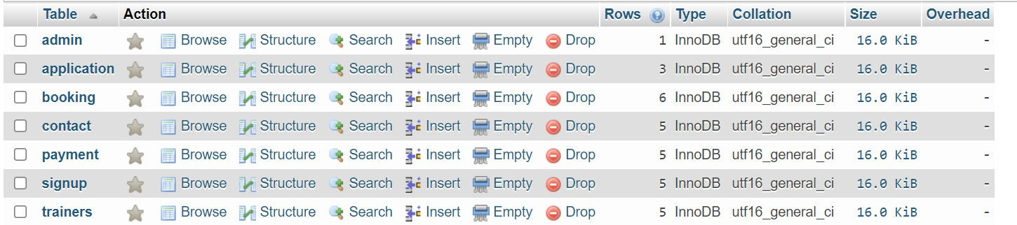

* + 1. **Admin table:**

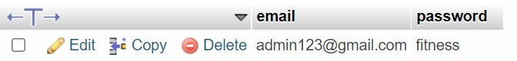

### Sign up table:

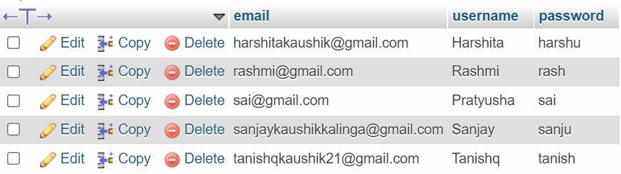

* + 1. **Booking table:**

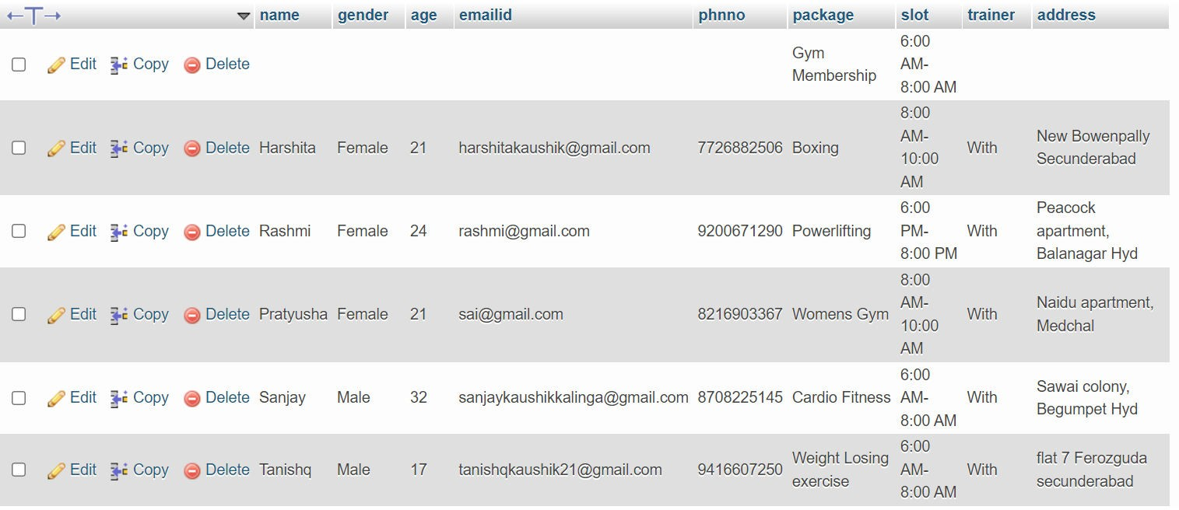

### Payment table:

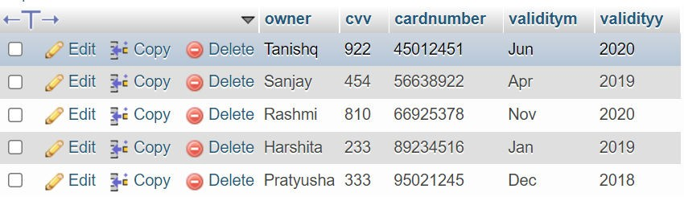

* + 1. **Contact table:**

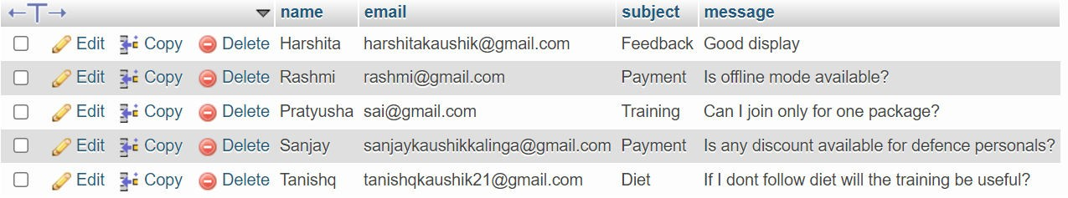

### Trainer table:

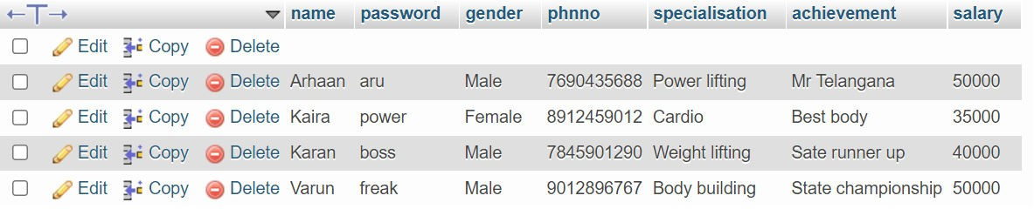

* + 1. **Leave table:**

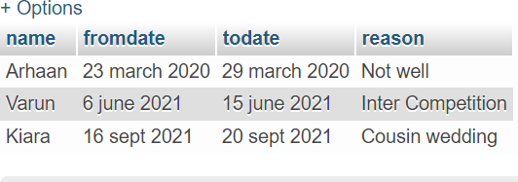

### RESULTS Main page:

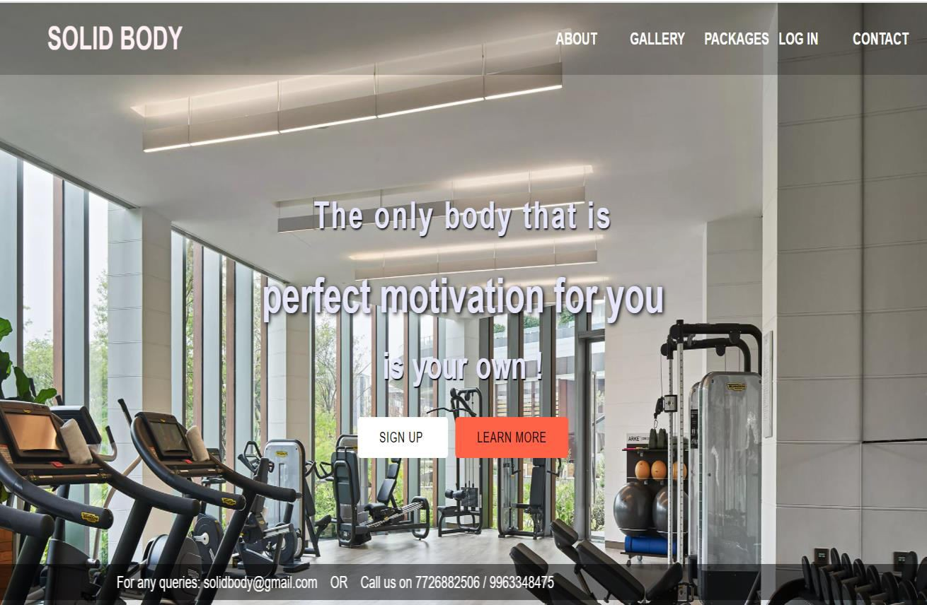

**About page:**

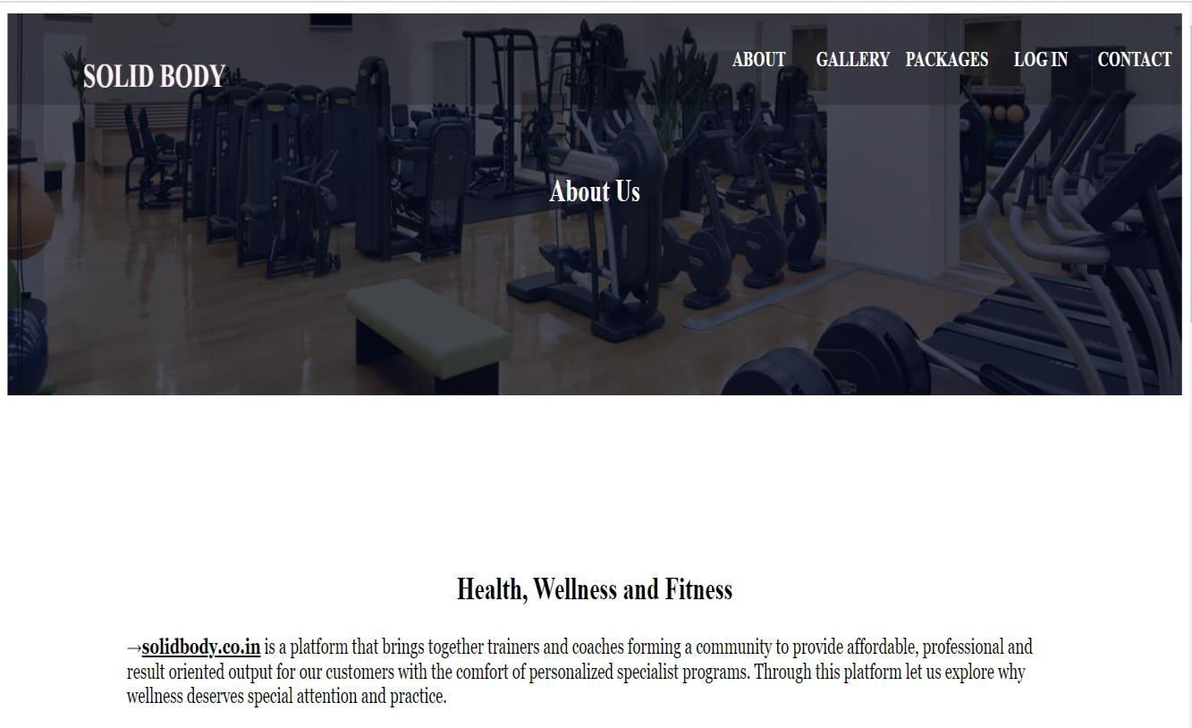



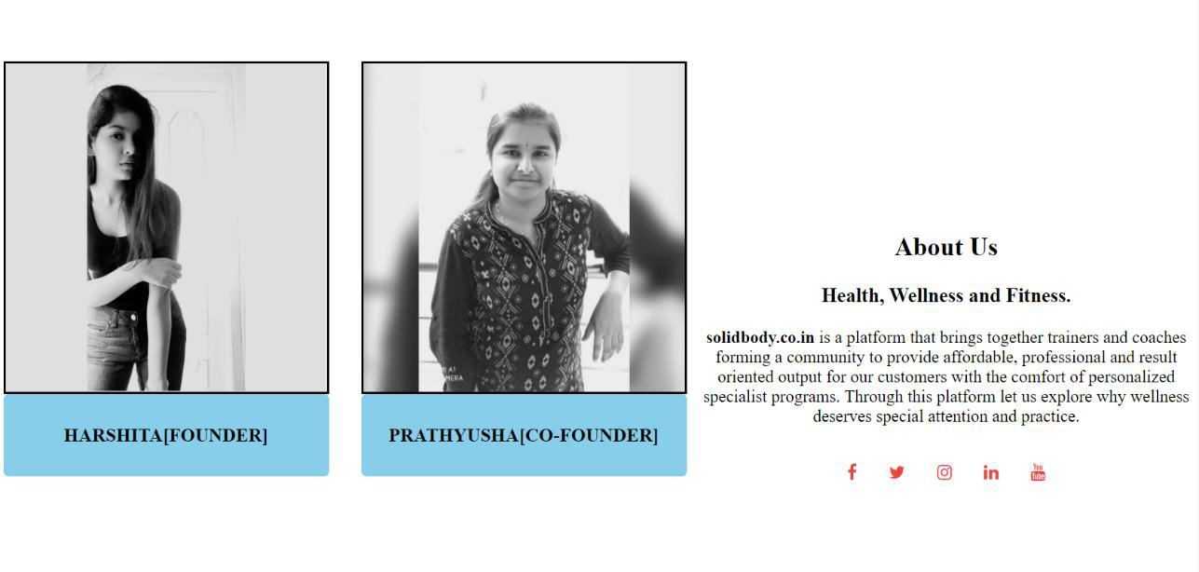

### Gallery page:

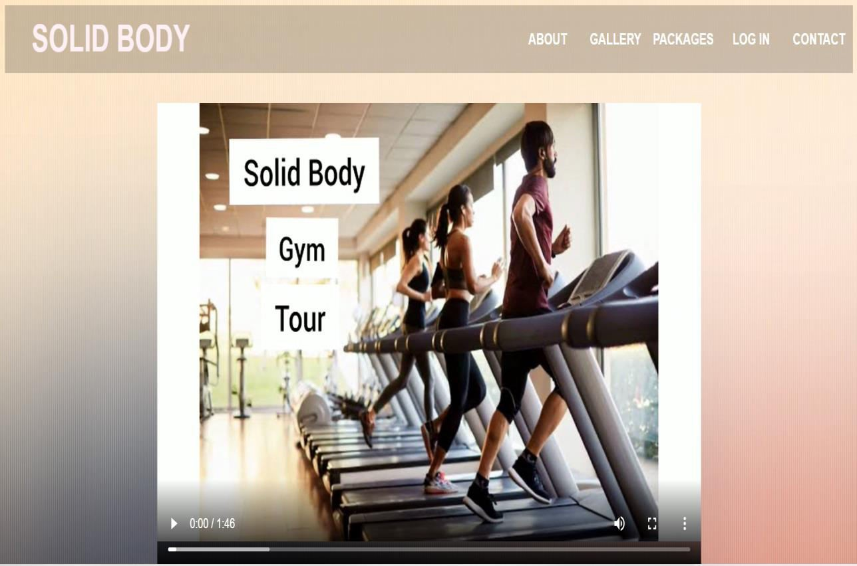

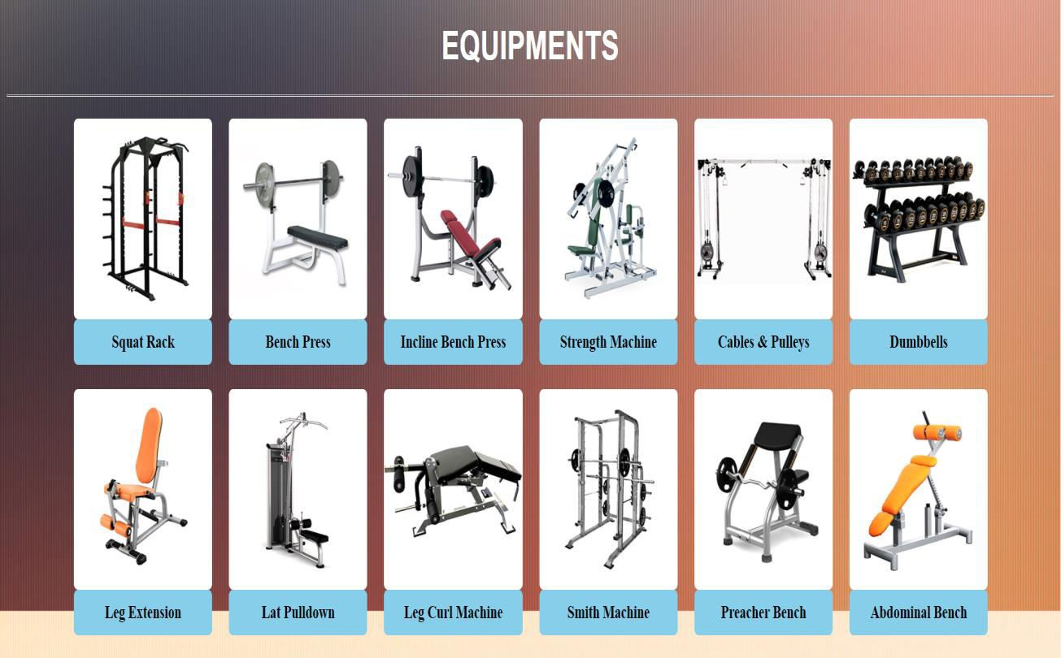

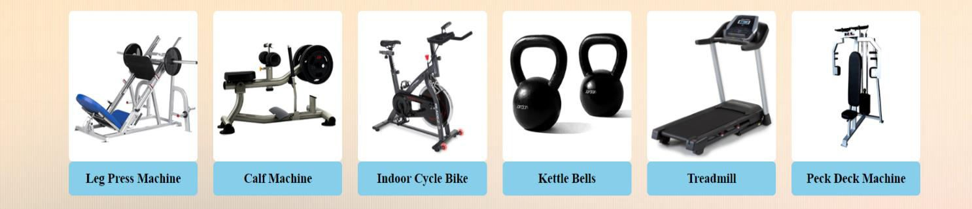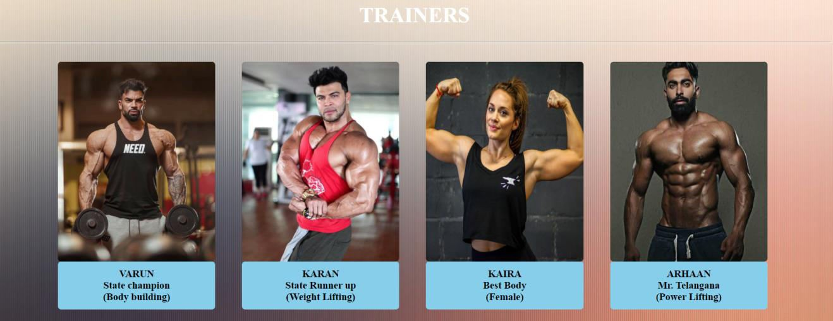

**Packages page:**

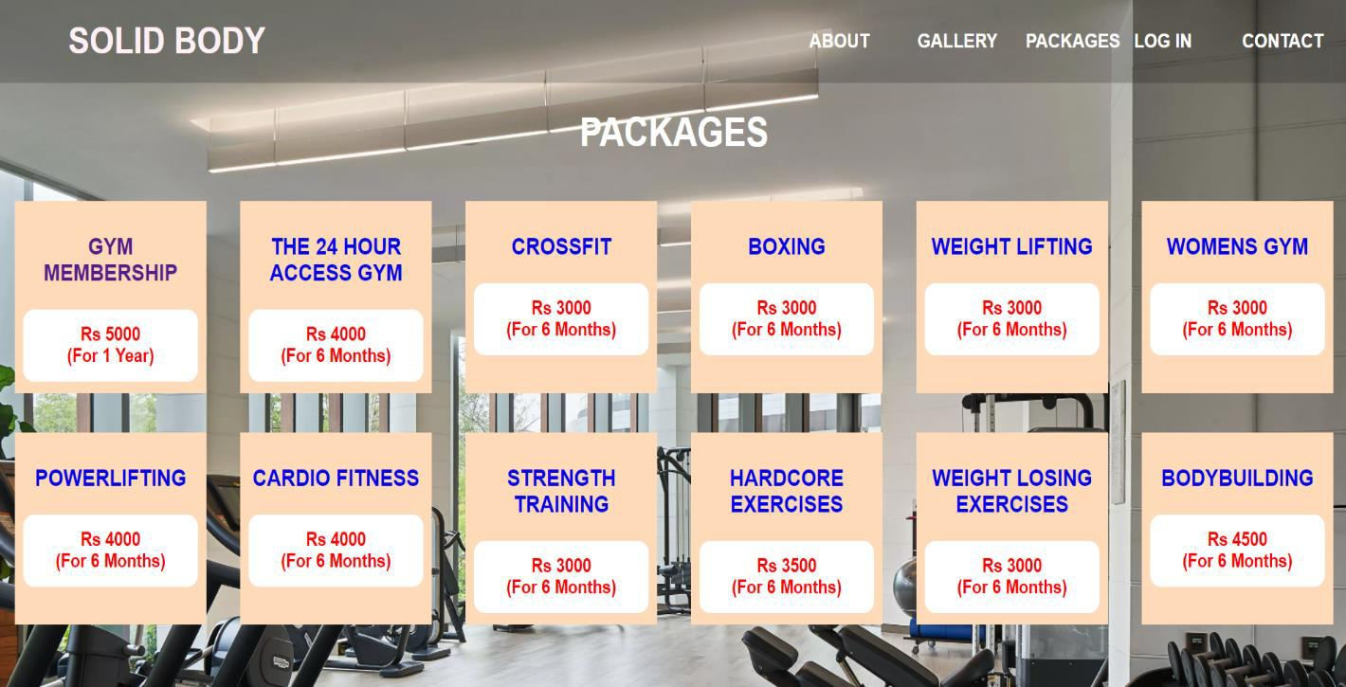

### Gym membership page:

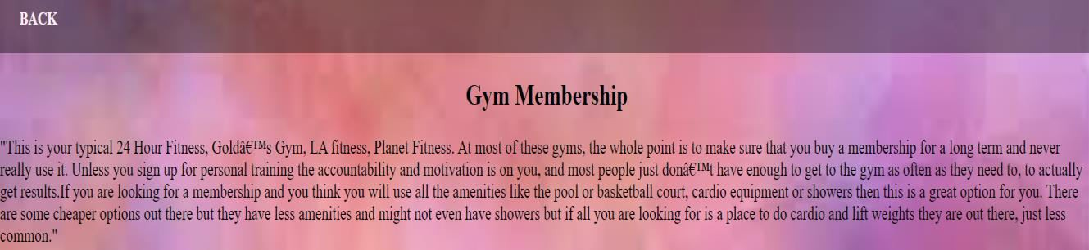

**24 hours access page:**

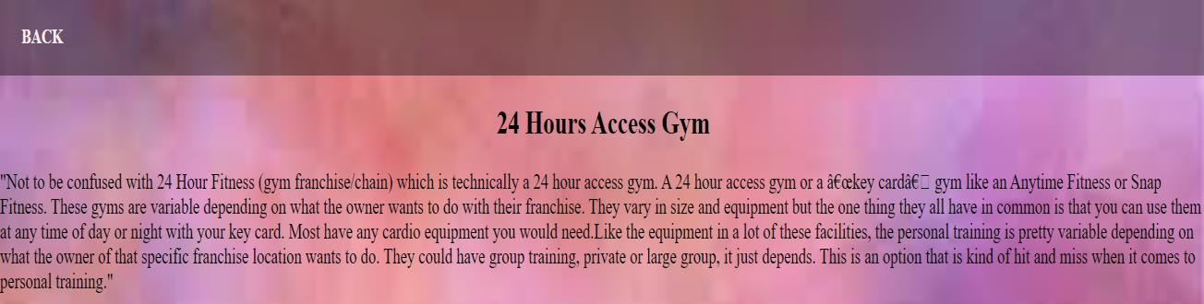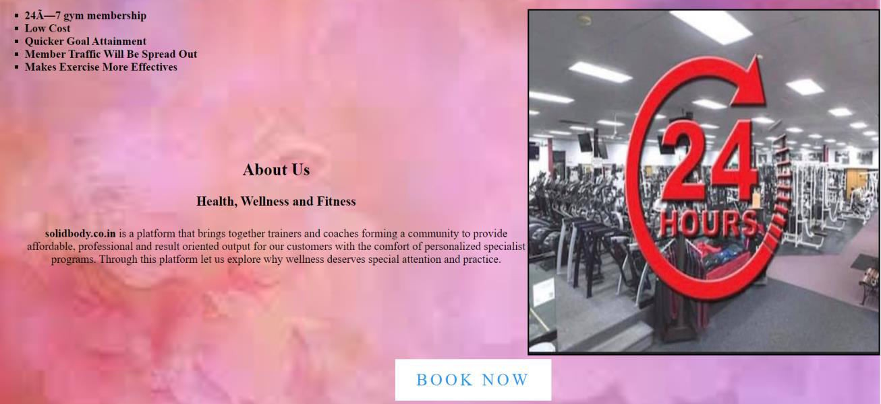

### Cross fit page:

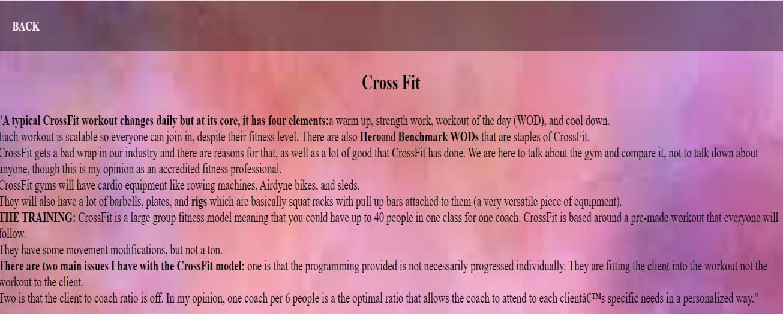

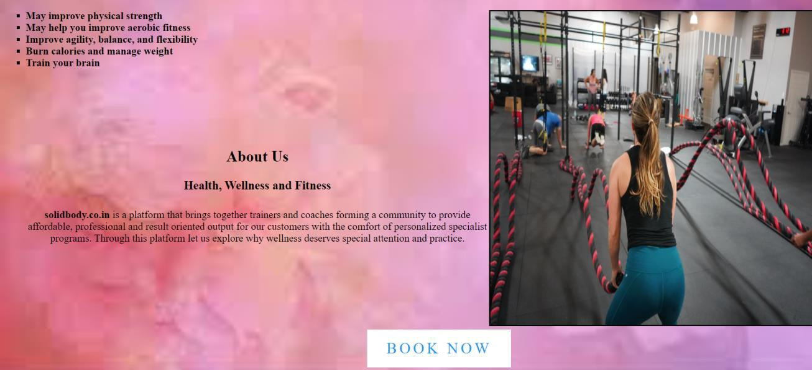

**Boxing page:**

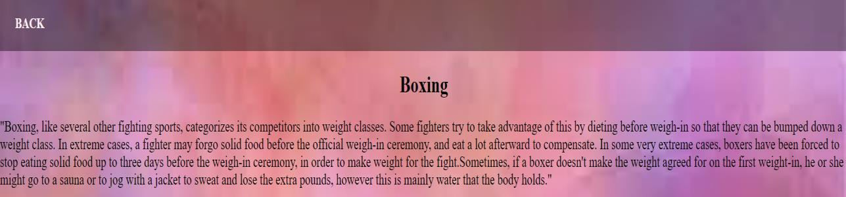

### Weight lifting page:

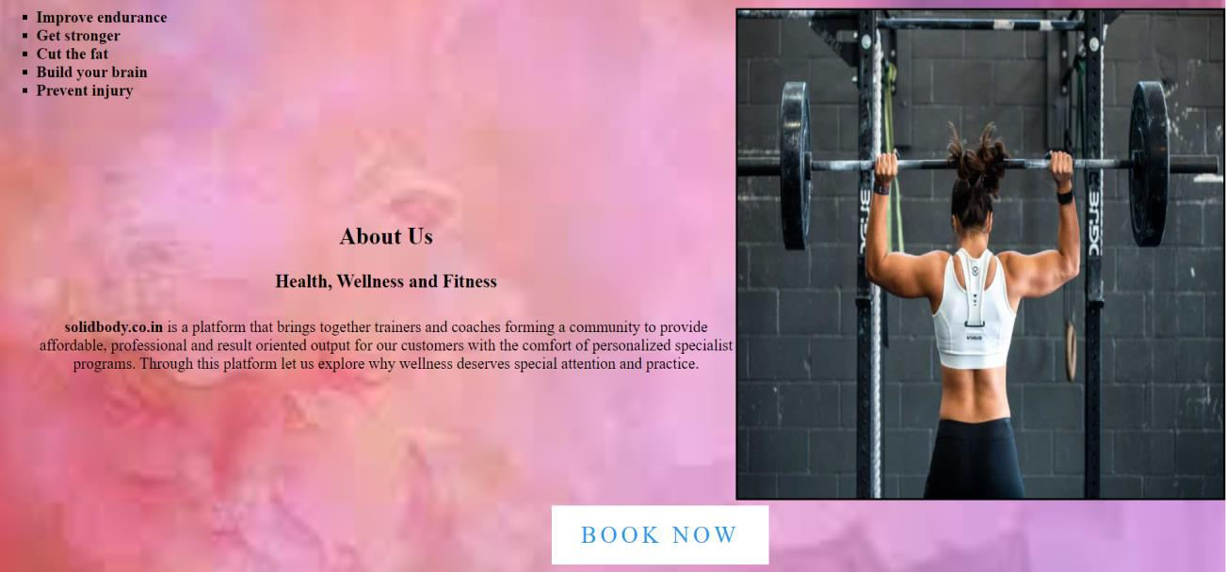

**Women’s gym page:**

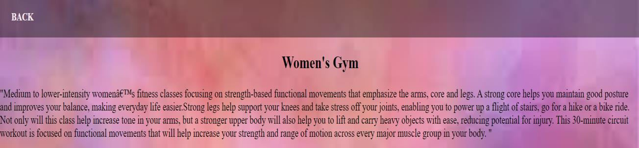

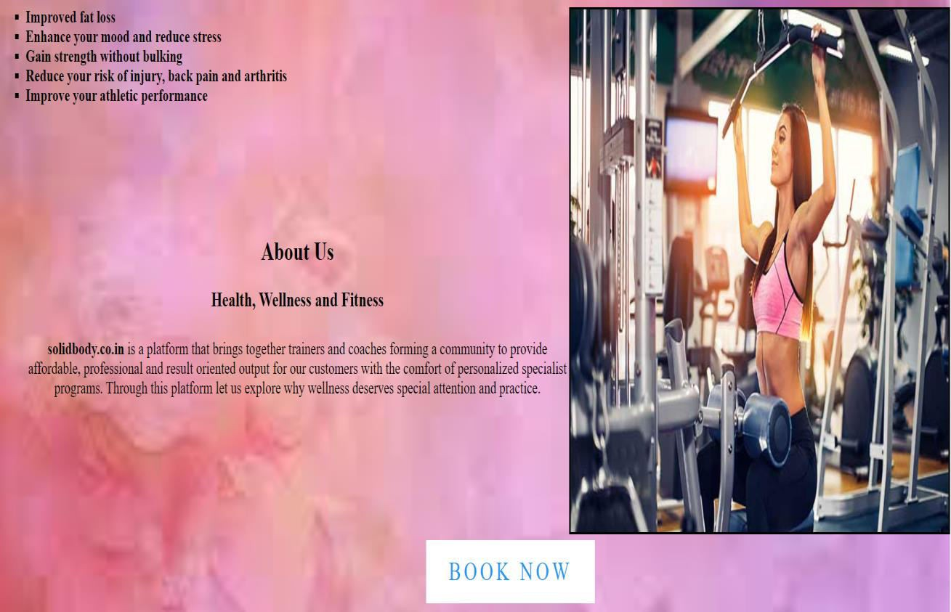

### Power lifting page:

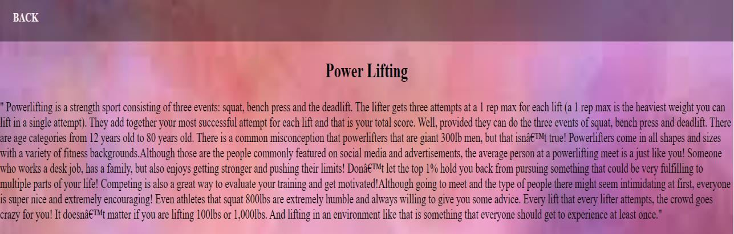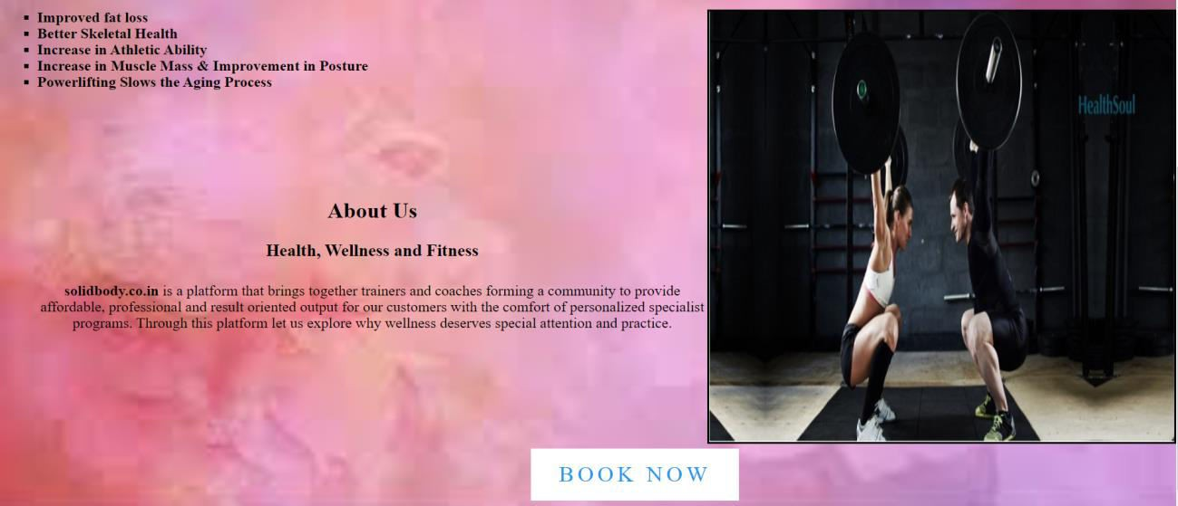

**Cardio fitness page:**

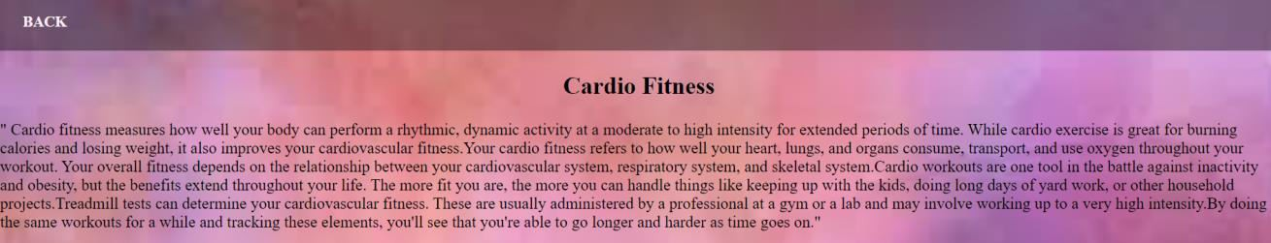

### Strength training page:

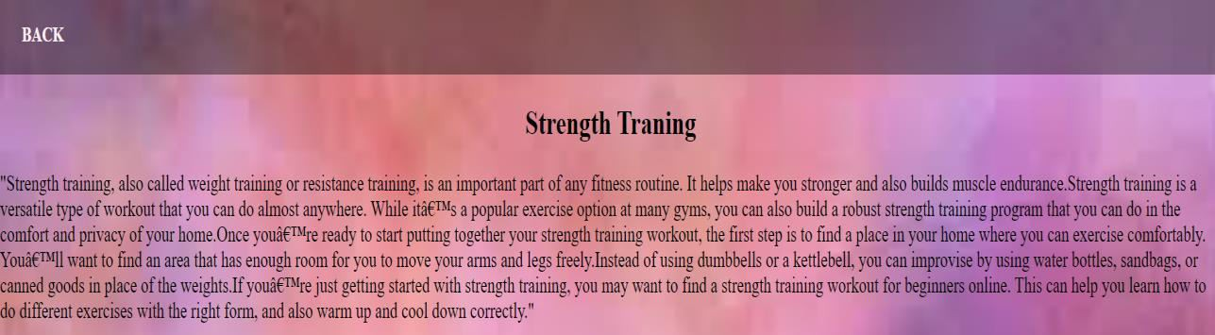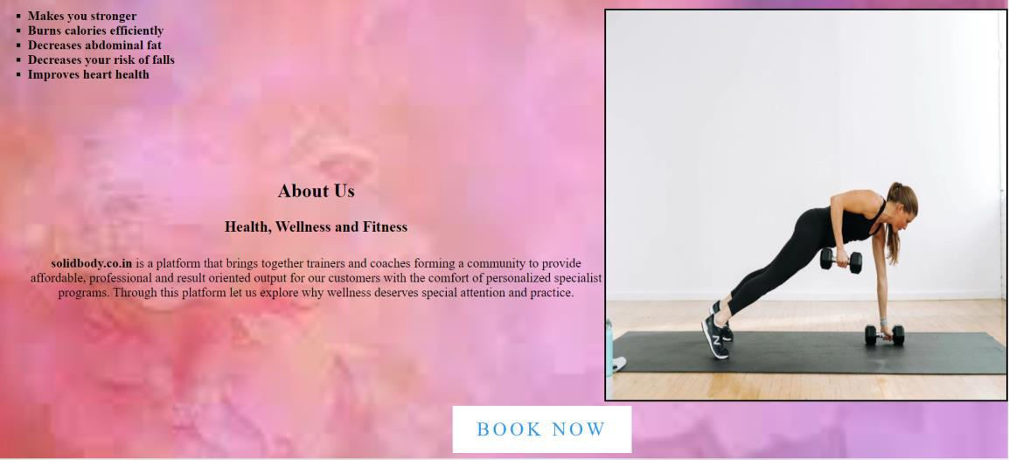

**Hard core exercise page:**

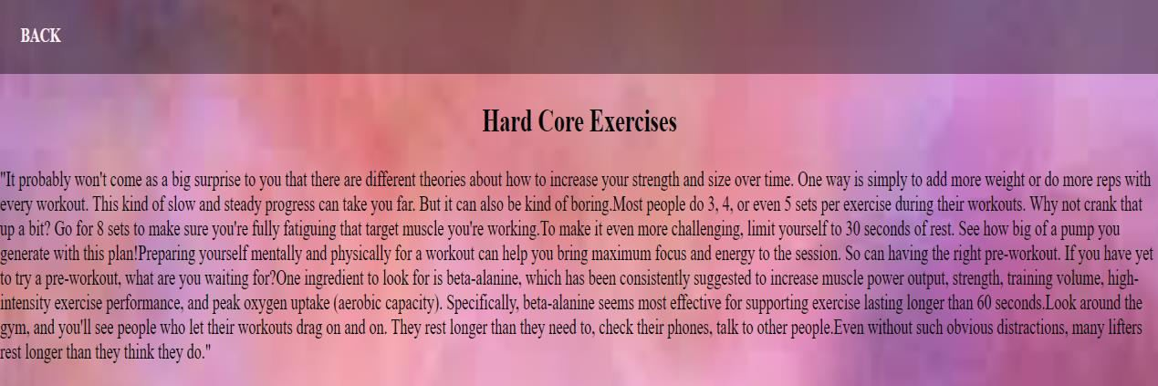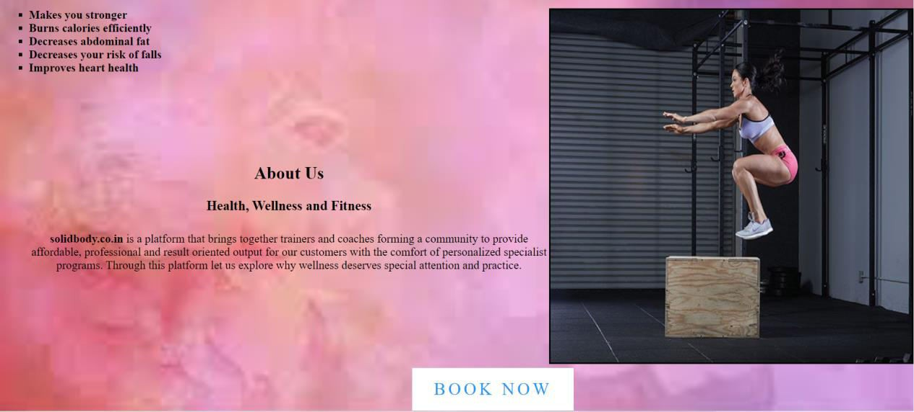

### Weight loss exercise page:



**Body building page:**

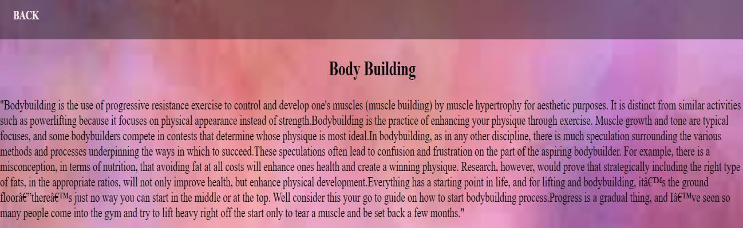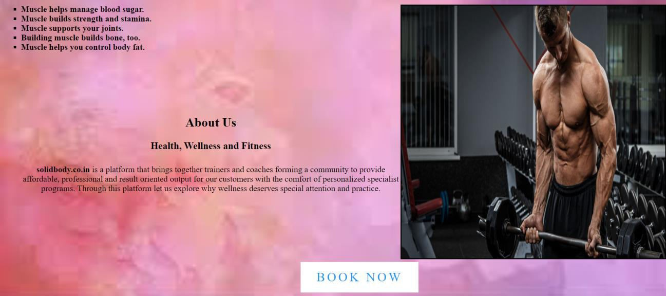

### Contact page:

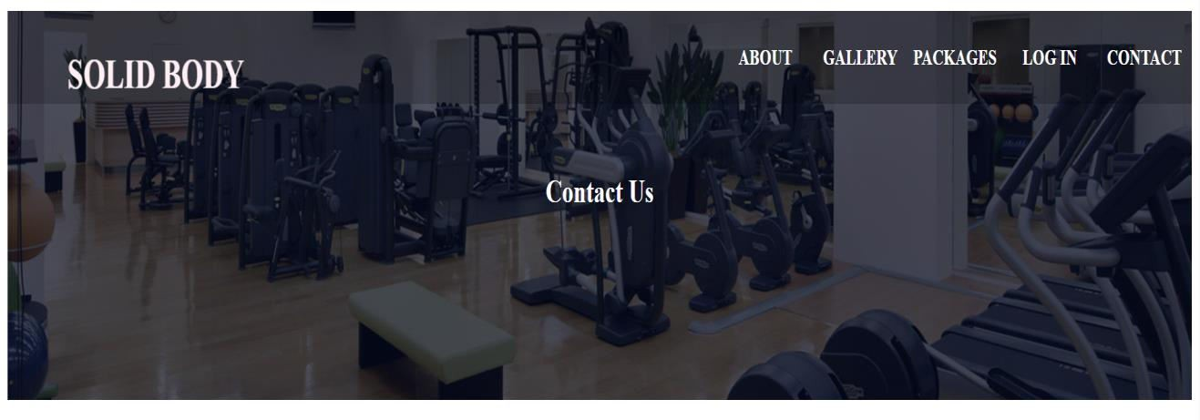

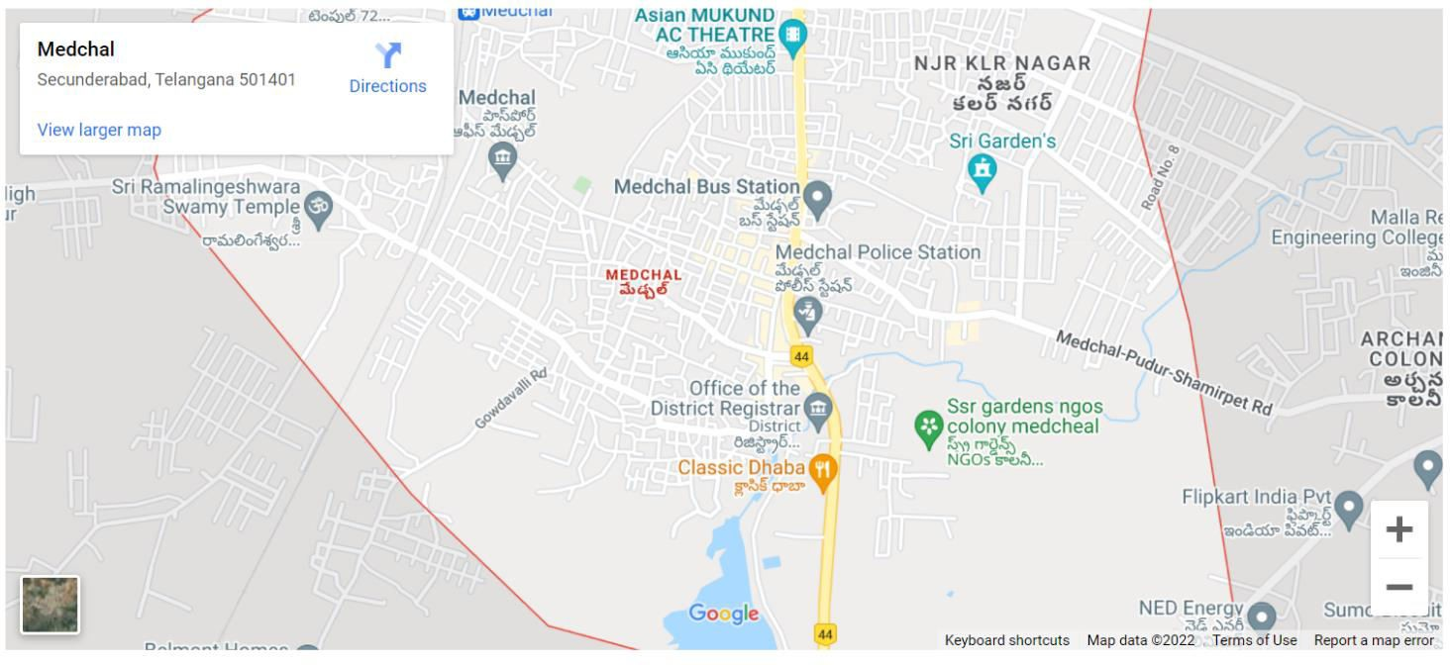



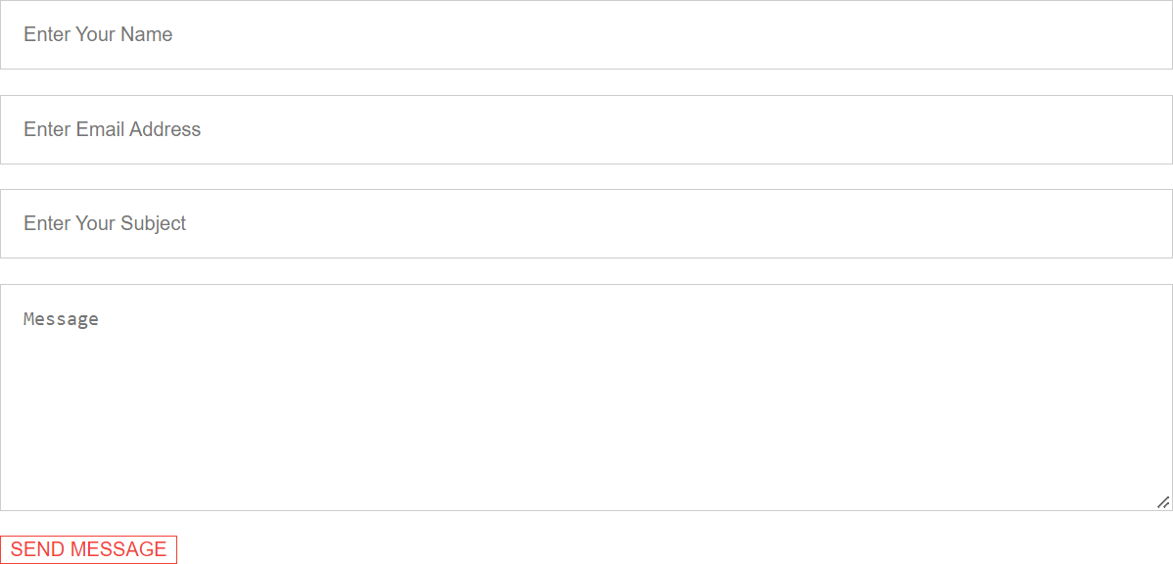

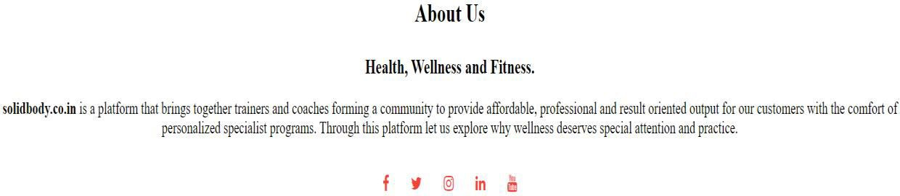

**Signup page:**

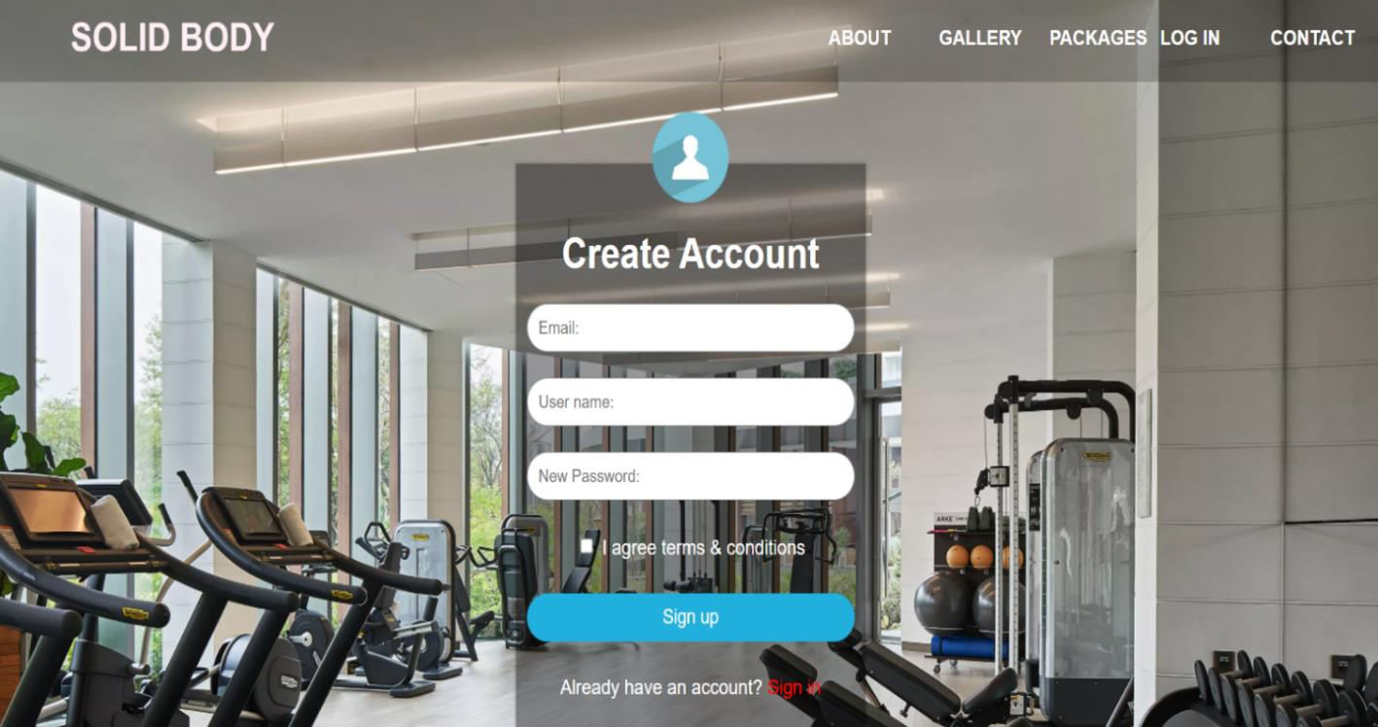

### Learn more page:

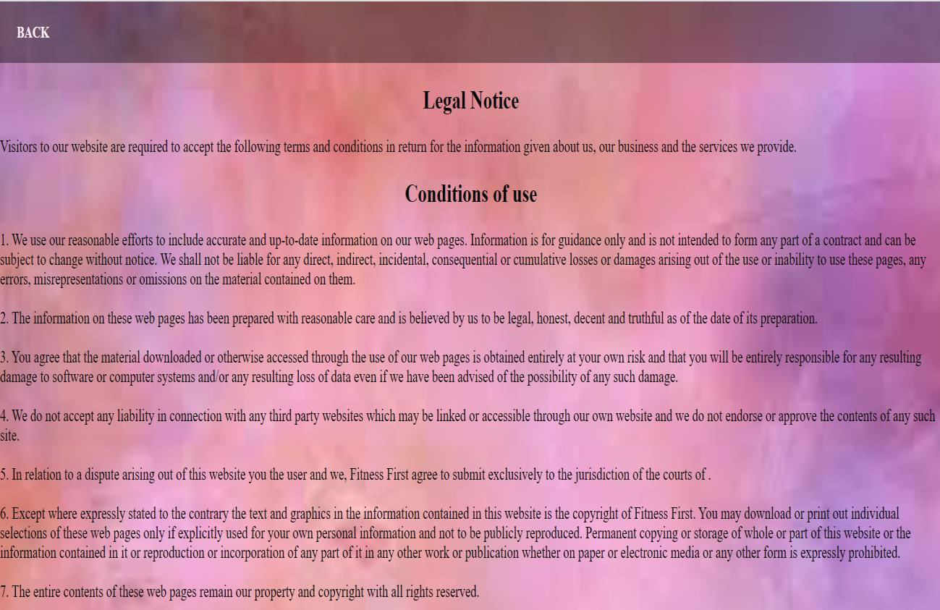

**User Login page:**

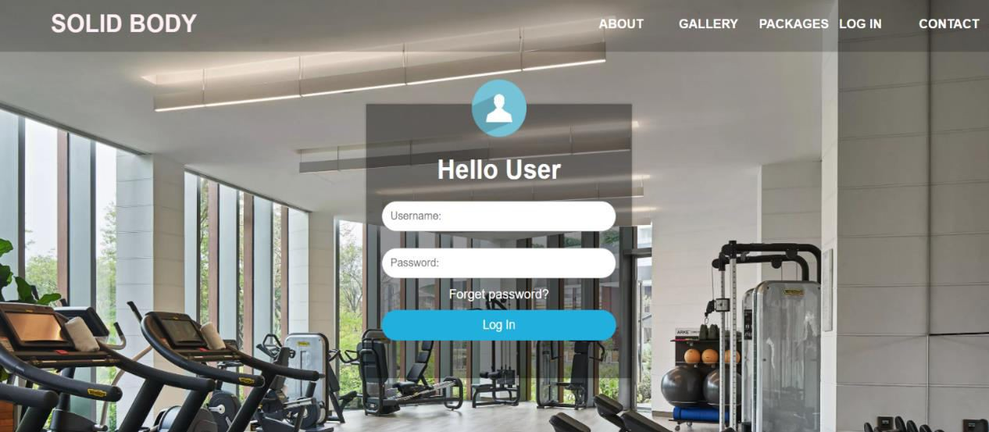

### User dashboard page:

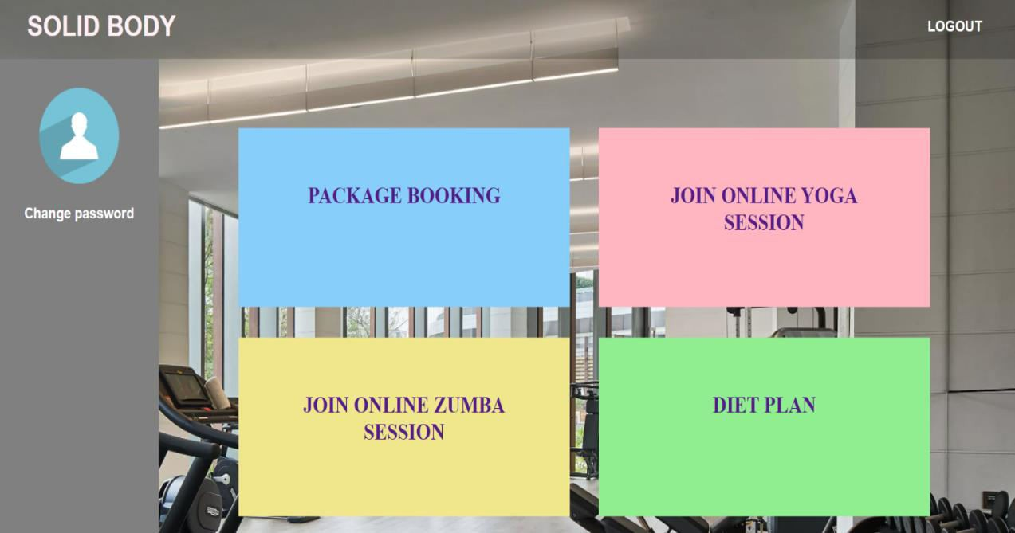

**Booking form:**

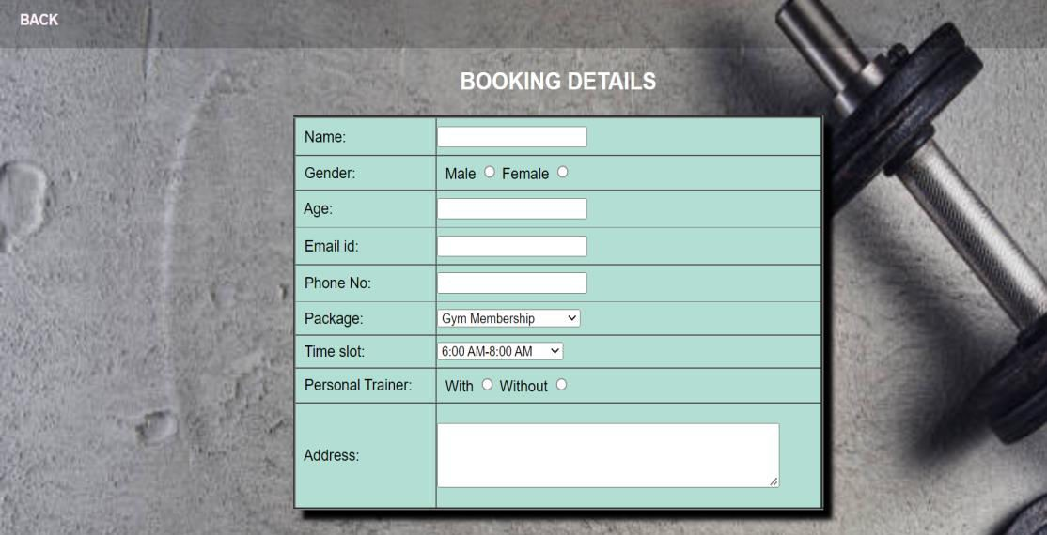

### Payment details page:

### 

### Yoga videos:

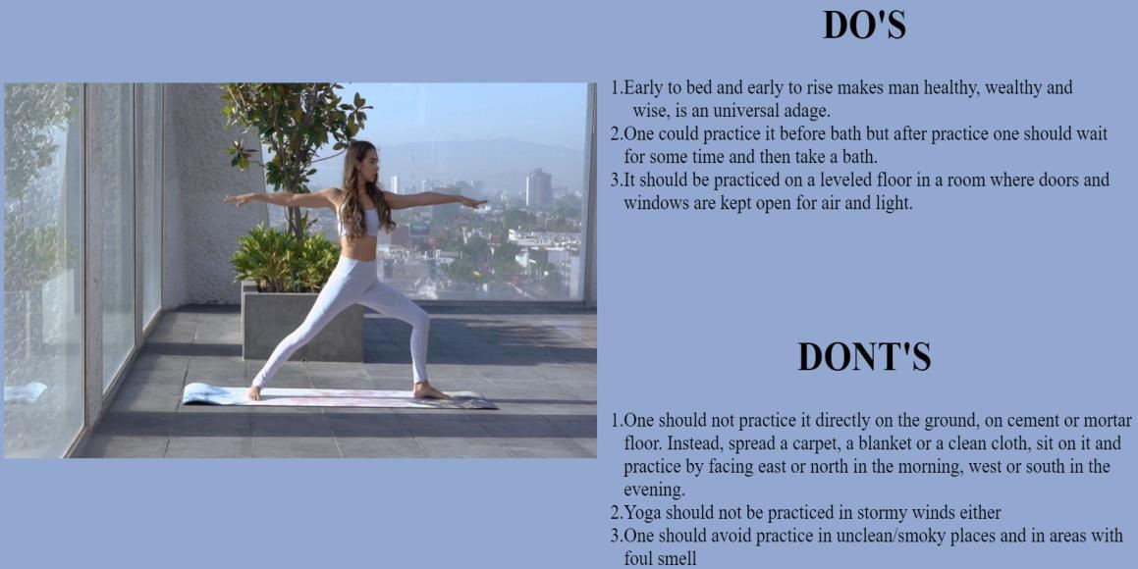

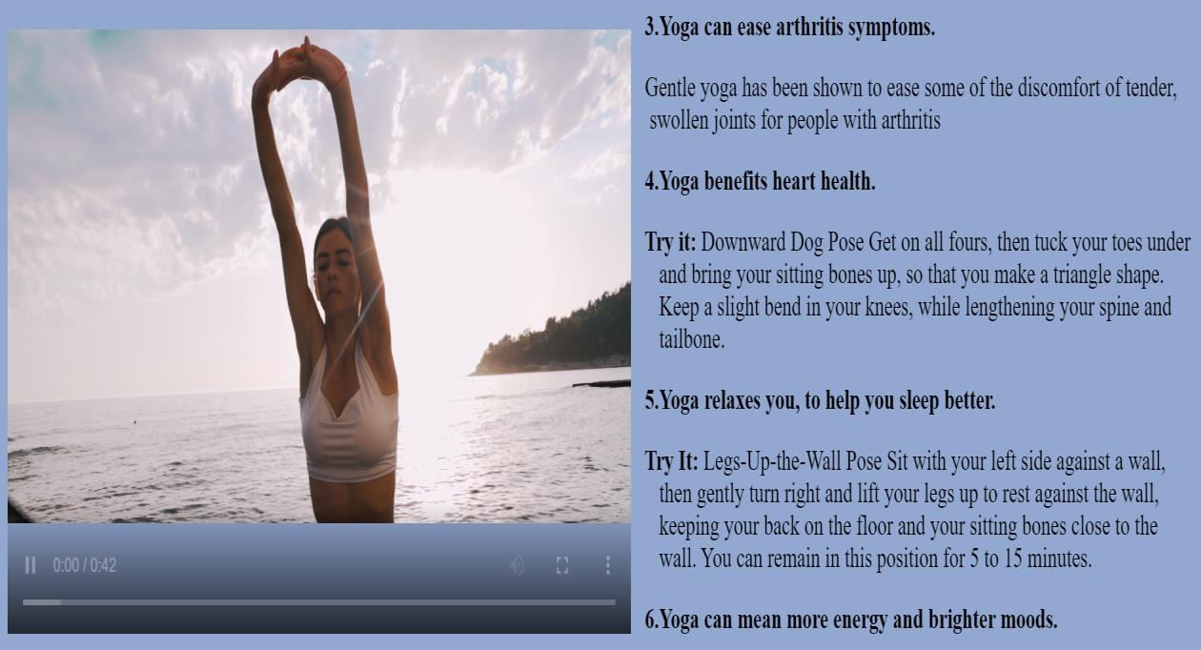

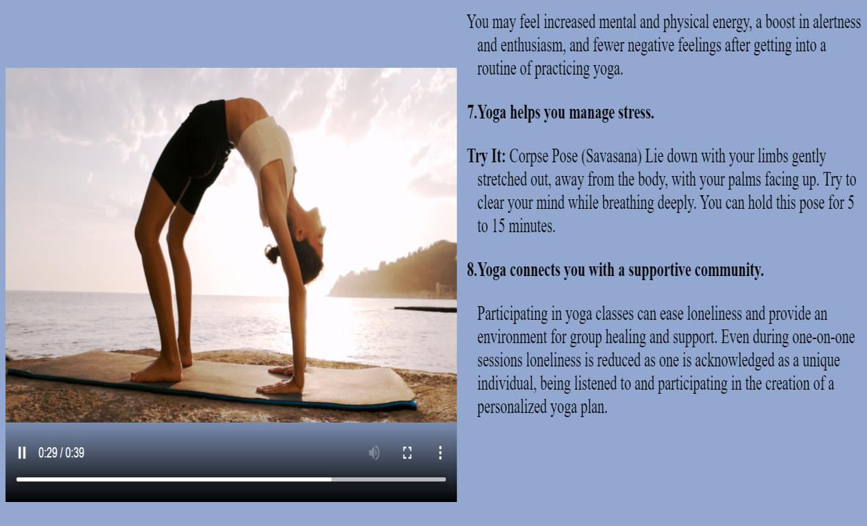

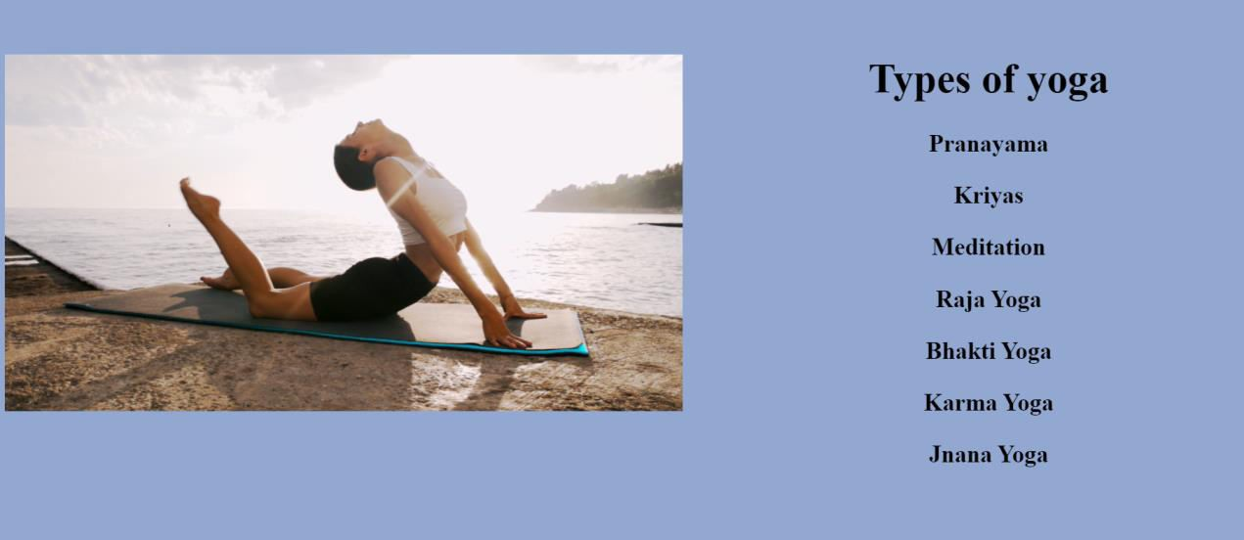

**Zumba videos:**

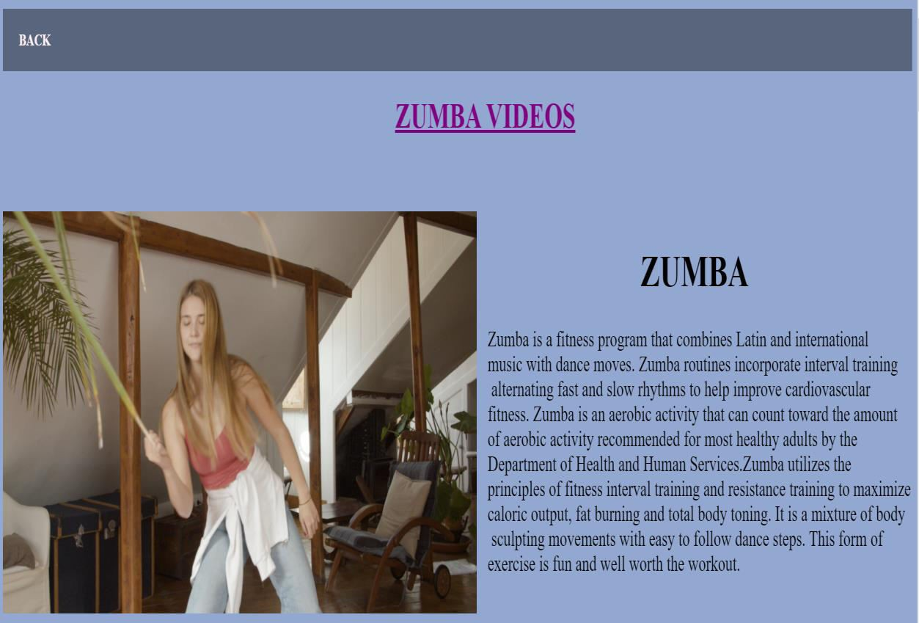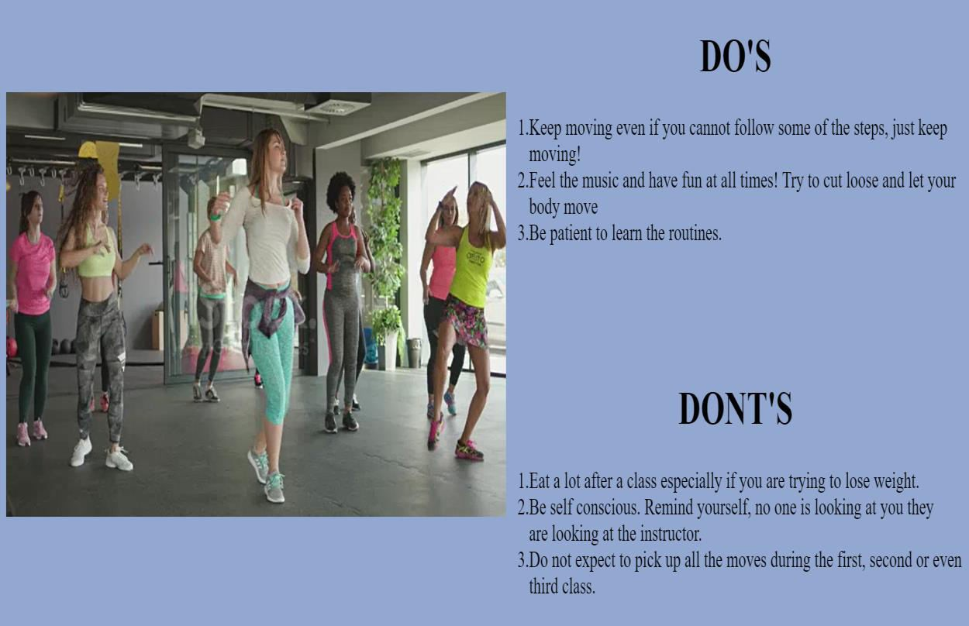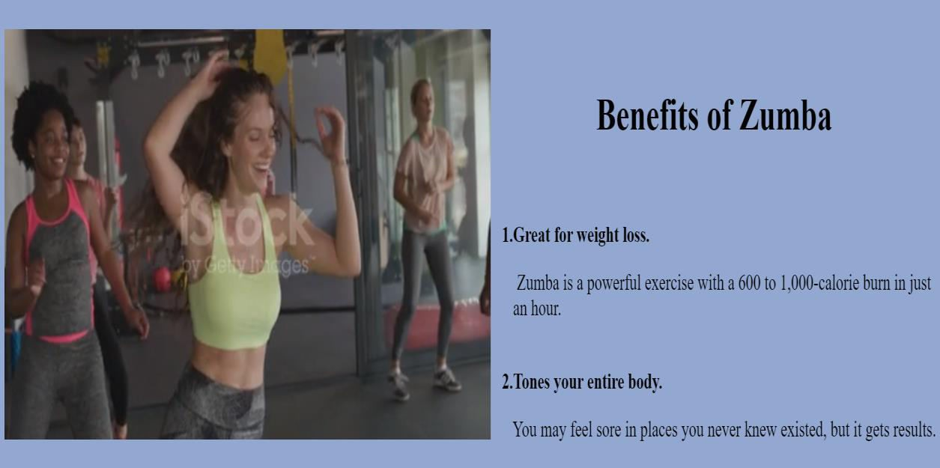

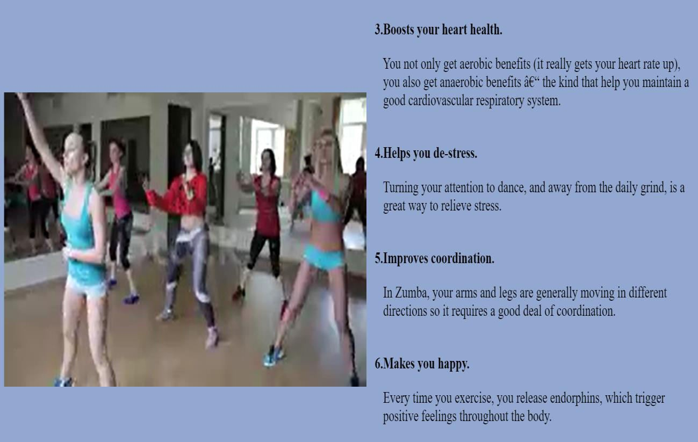

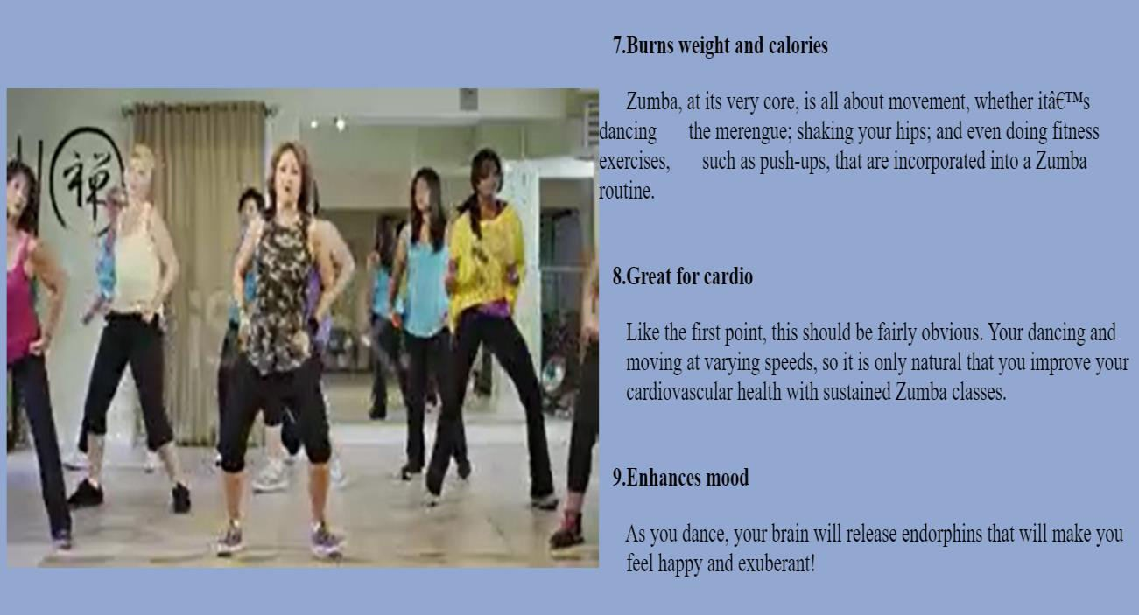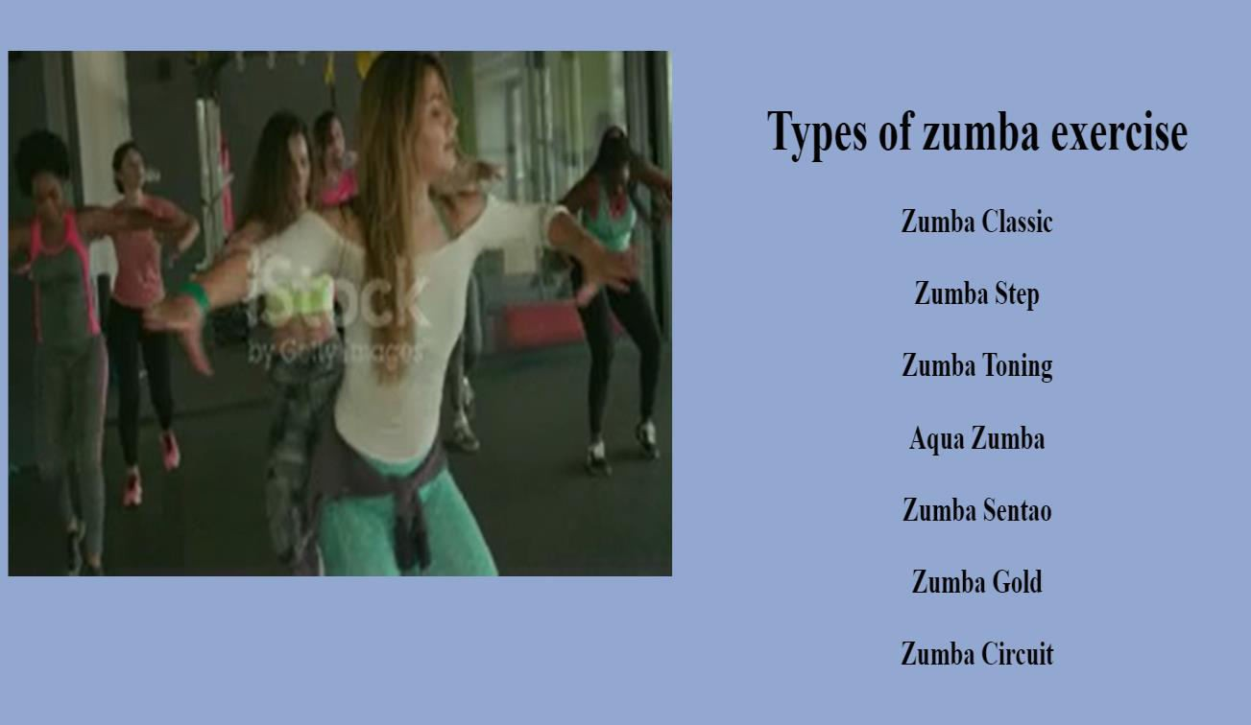

### Diet:

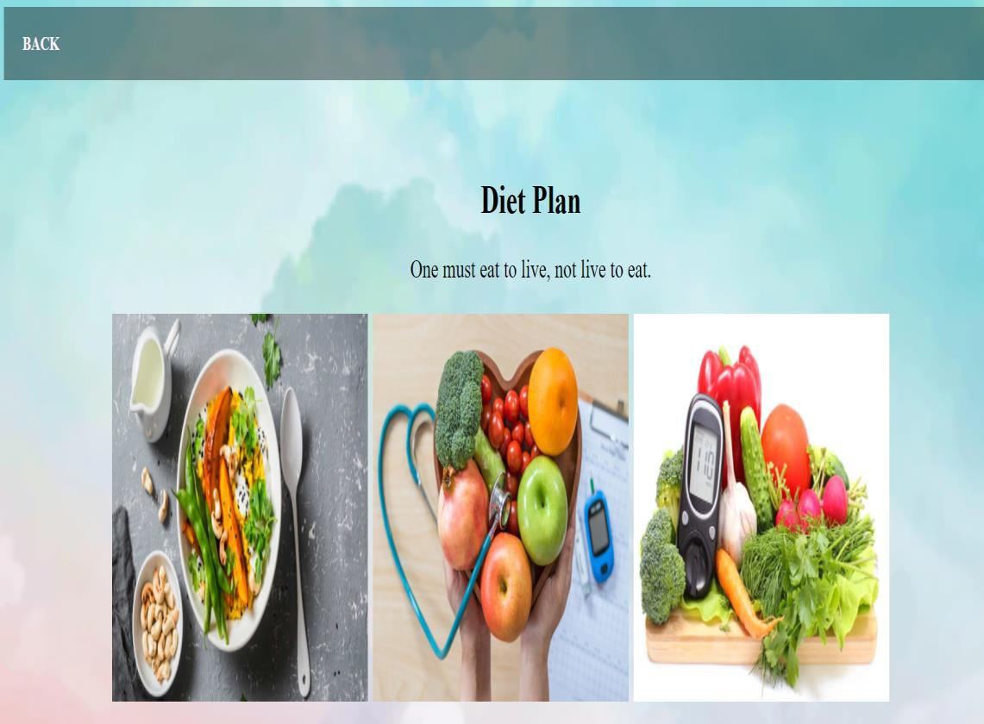

**Update password page:**

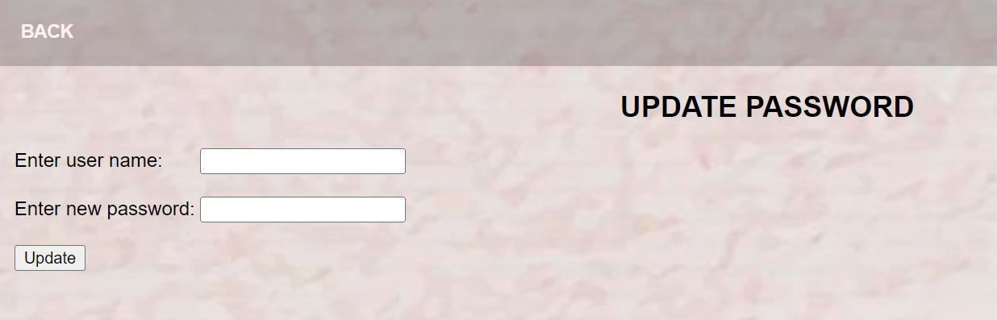

### Rating page:

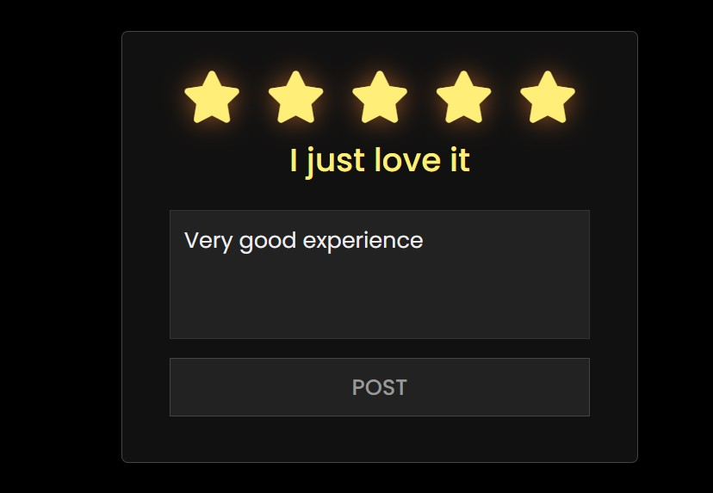

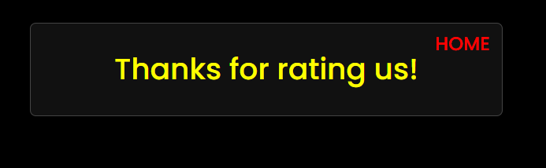

**Trainer login page:**

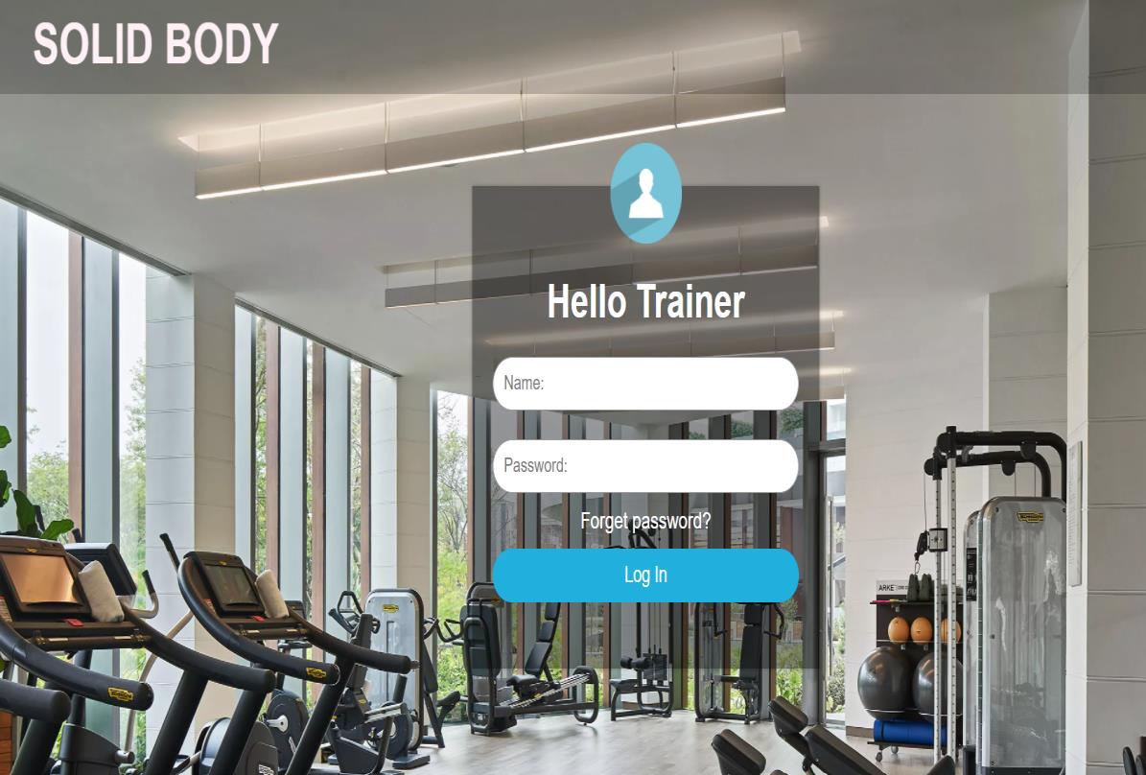

### Trainers page:

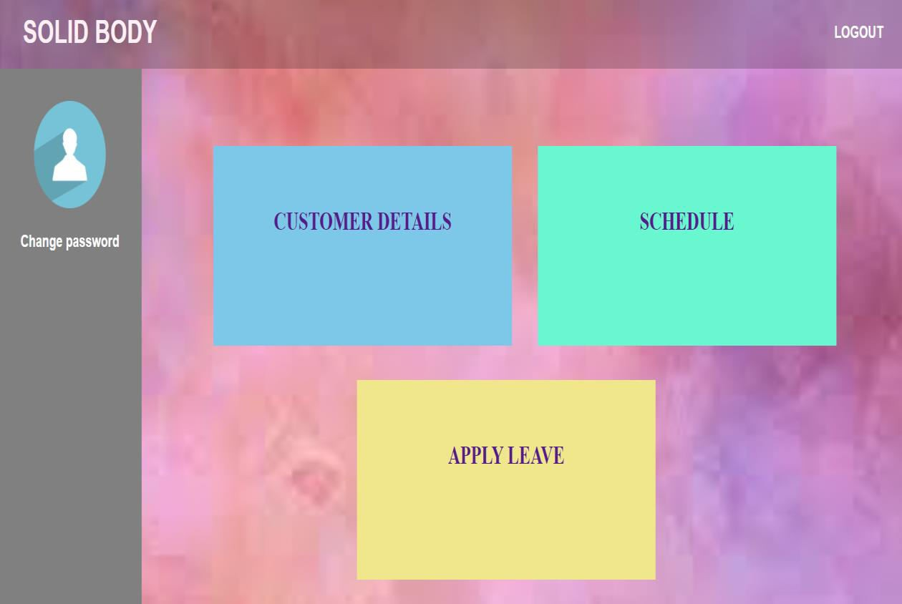

**Customer details page:**

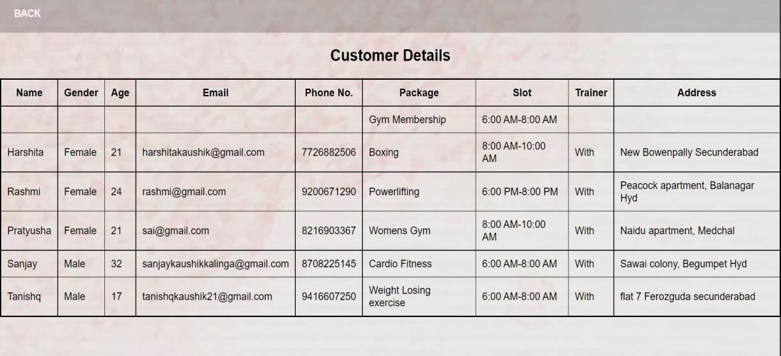

### Schedule page:

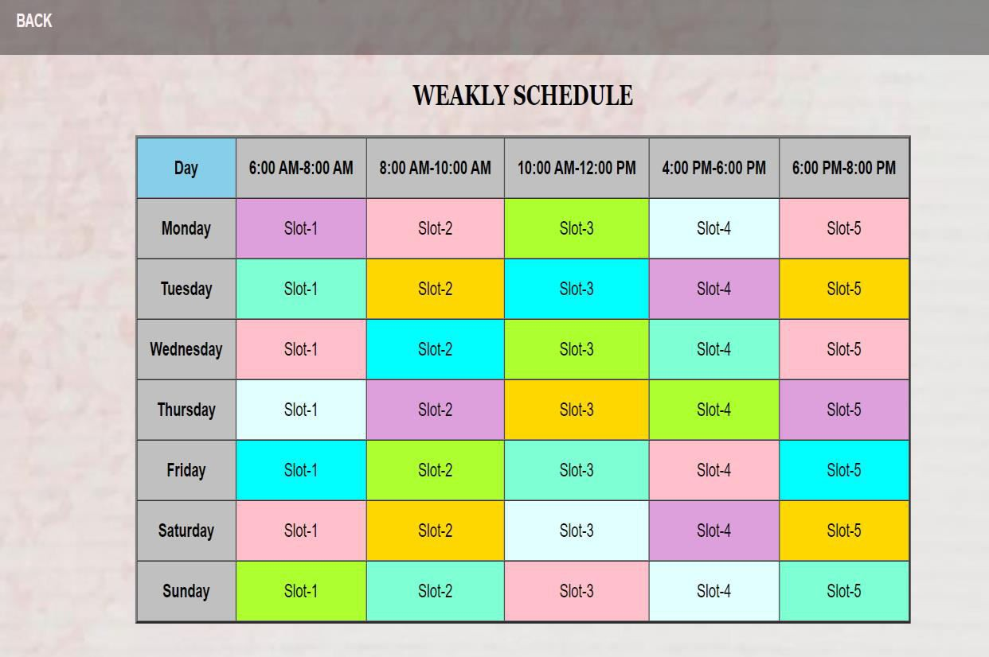

**Leave page:**

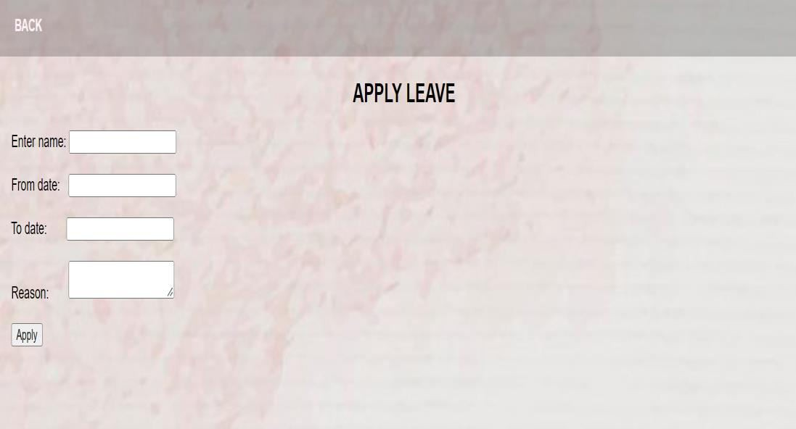

### Update password:

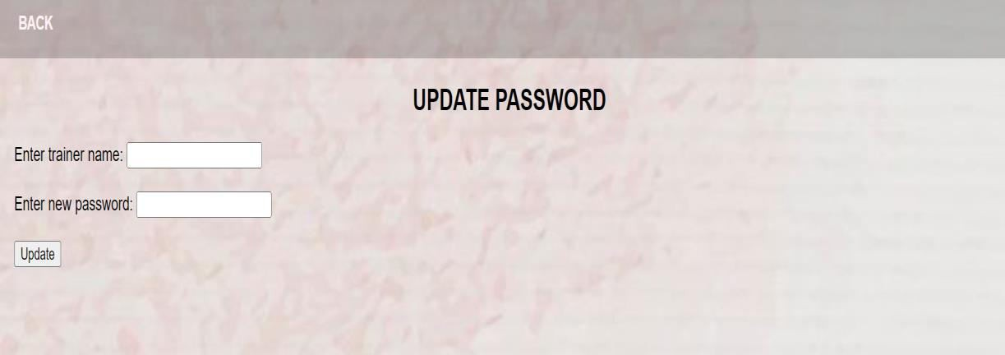

**Admin login form:**

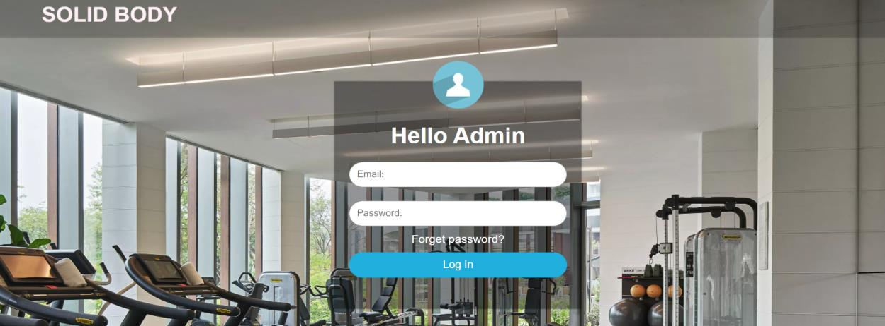

### Admin dashboard page:

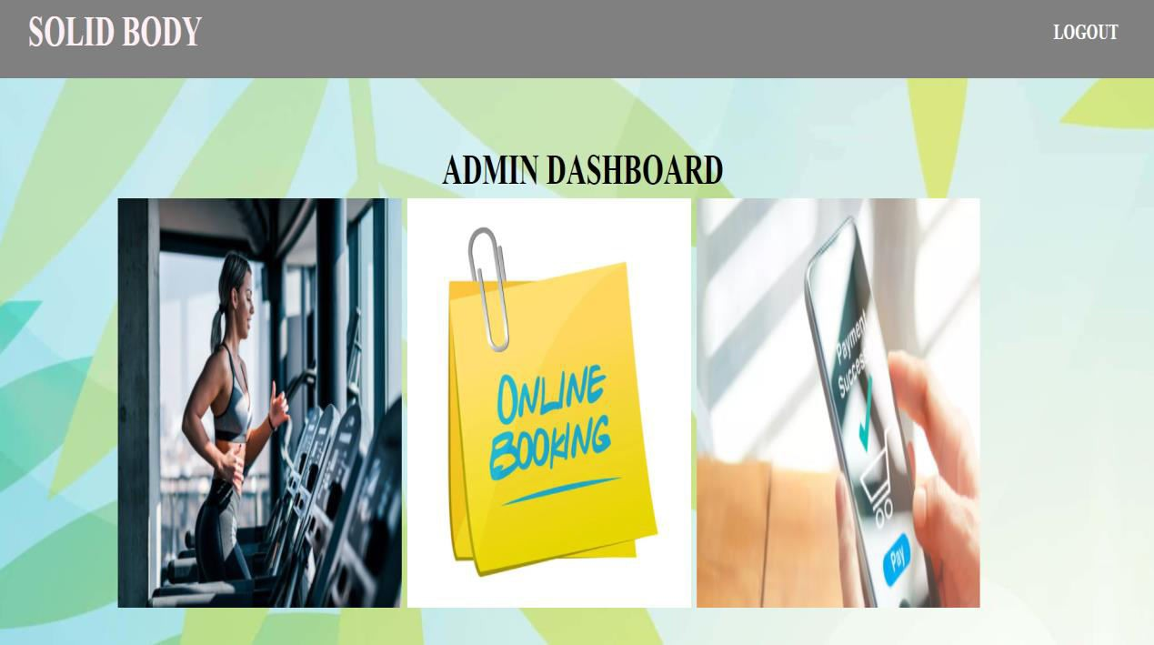





**User data:**

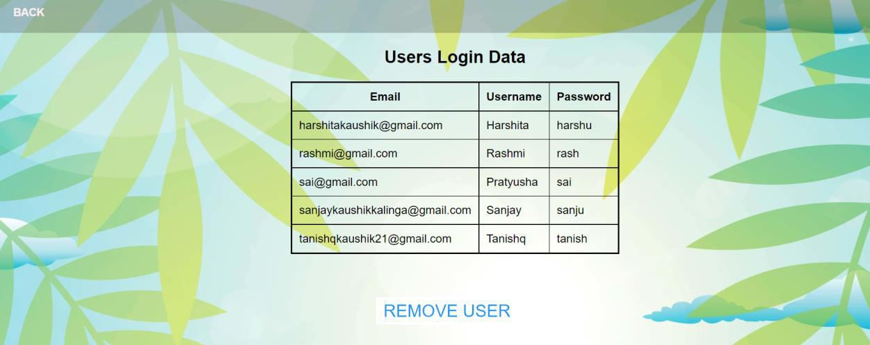

### Remove user page:

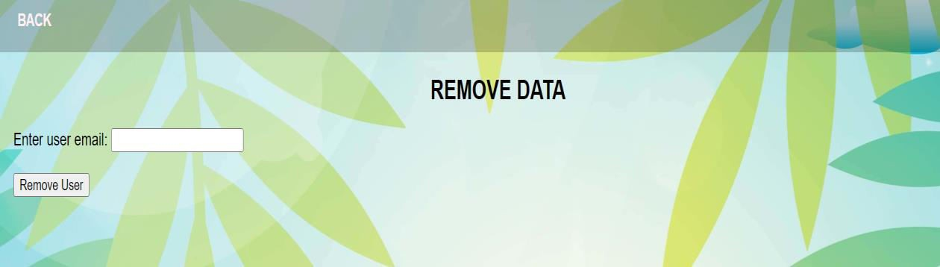

**Booking data page:**

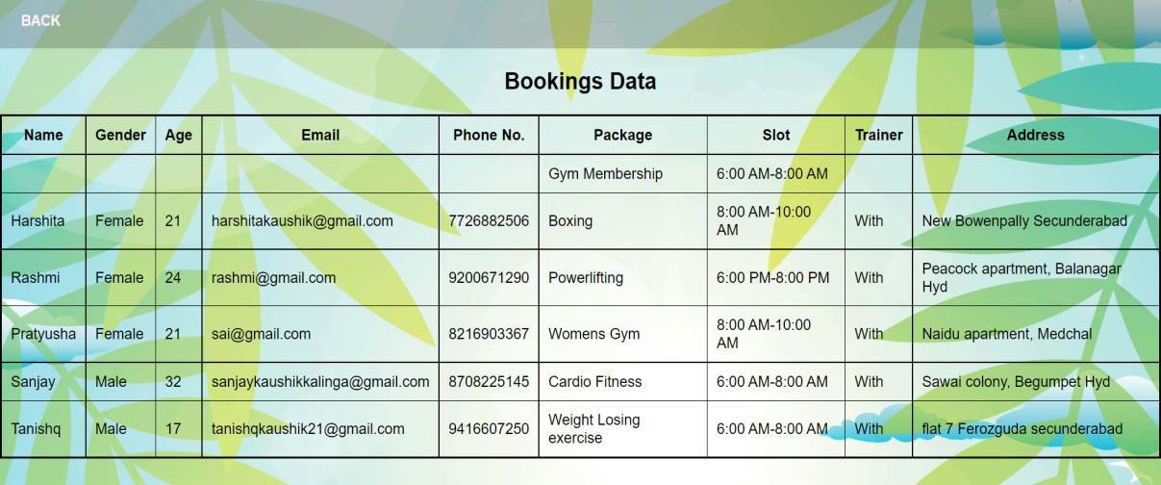

### Payment data page:

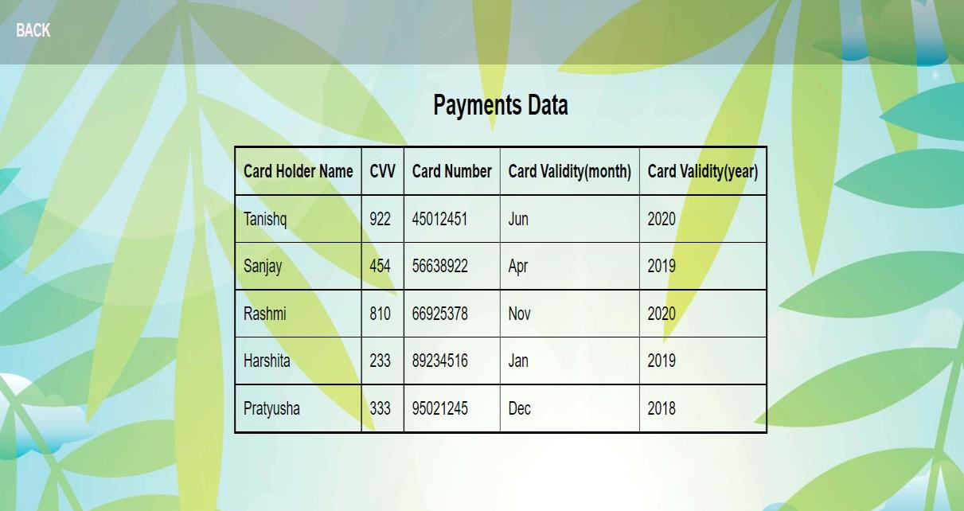

**Trainers data page:**

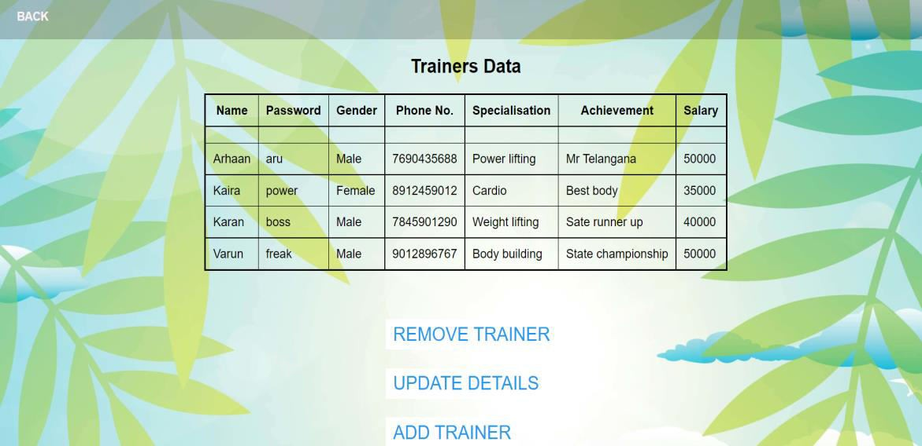

### Remove trainer page:

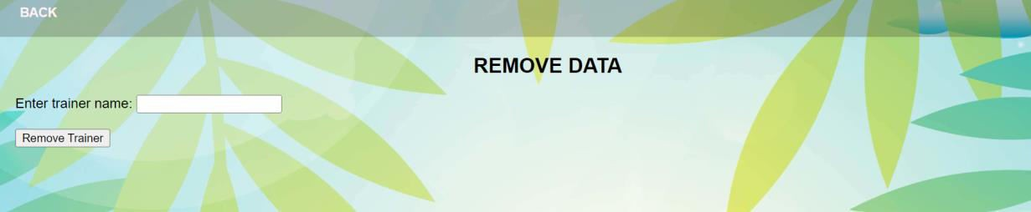

**Update trainer:**



### Add trainer page:

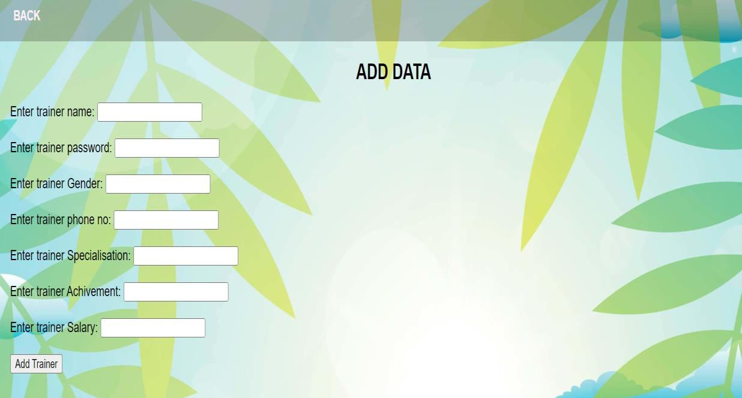

**Message data page:**

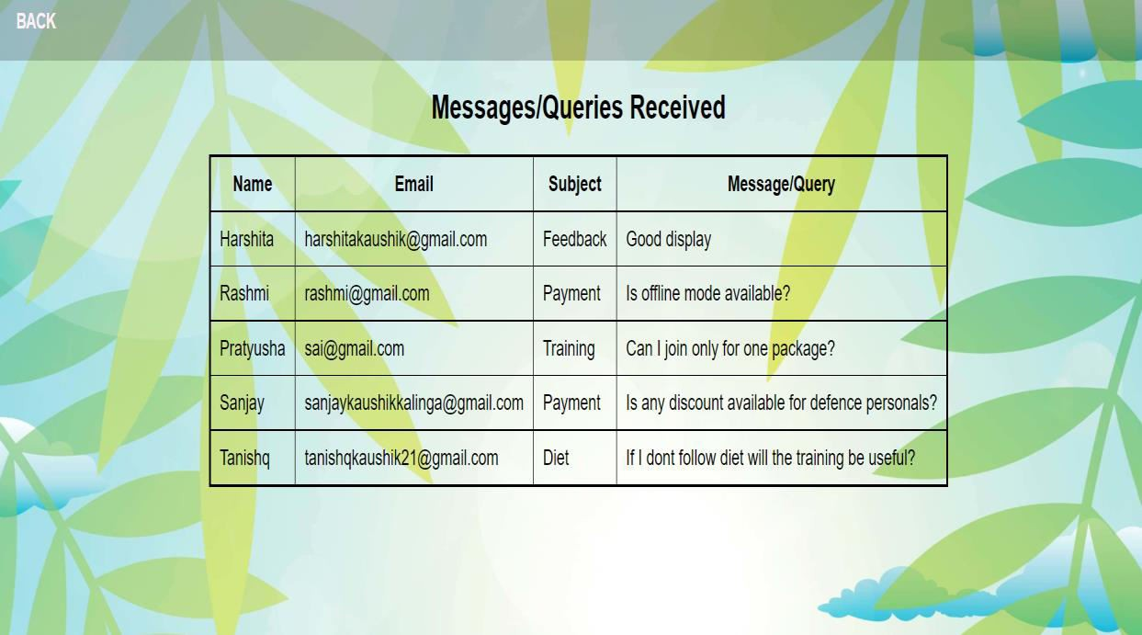

**Apply leave page:**

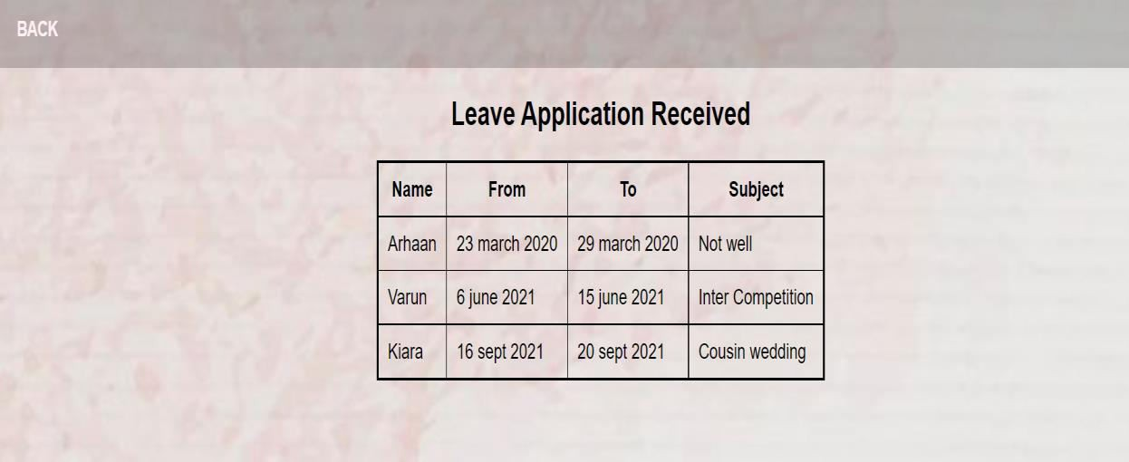

# CHAPTER 5 CONCLUSION

## CHAPTER-5 CONCLUSION

### CONCLUSION

The demand of Web application for application is increasing day by day in Software industry, due to high expectations of client companies.

Hence an attempt of automating an office application had added to our learning experience.

It has also helped in adopting an analytical approach to solving and made us realize that system development is a step-by-step process.

Our project Gym Management System provides user to make package booking online. It provides user with a provision to view content of all the packages offered by the gym and can search the services in detail and can make a booking. This system holds information about gym members, equipments, packages, trainers and also diet plan.

This project has proven to be a worthwhile exercise for us !! Stay healthy…

### LIMITATIONS OF THE SYSTEM

Gym Management System project is always a room for improvement, it should be flexible enough for future modifications. The “Gym Management System” website although having many functionalities and being user-friendly has a few limitations.

* + - Since it is an online project, users need good and stable internet connection.
    - Not offering a monthly package booking.
    - Data security
    - People who are not familiar with computers can’t use this website.
    - There is no option for cancellation of booking or refund.
    - The system fails if the server fails.

### FUTURE SCOPE

This “Gym Management System” involves all the features of the online booking. The future implementation will be online help for the users and contacting us through website.

Our marketing strategy will be based mainly on ensuring fitness freaks know about our existence and the services we fulfil. Hence our intention is to make the right information available to the right target users. We will ensure that our prices take into consideration people’s budgets that these people appreciate the services, know that it exists, and how to contact us.

Our services will be positioned very carefully, they will be of extremely high quality, comfortable, informative and tailored to the user’s needs. And will definitely work on the feedbacks given by our users for making our services better.

We will aware people about the benefits that physical activities are cure for many diseases from which lot of people suffering now a days.

Spending on gym was earlier seen luxury, but now it is a way of life, health and fitness will continue to remain at the forefront for all of us.

### REFERENCES

For PHP

* + - [www.w3schools.com/php/default.asp](http://www.w3schools.com/php/default.asp)
    - [www.tutorialspoint.com/php/index.htm](http://www.tutorialspoint.com/php/index.htm)
    - [www.javatpoint.com/php-tutorial](http://www.javatpoint.com/php-tutorial)

For MySQL

* + - [www.w3schools.com/mysql/](http://www.w3schools.com/mysql/)
    - [www.tutorialspoint.com/mysql/mysql-introduction.htm](http://www.tutorialspoint.com/mysql/mysql-introduction.htm)

For XAMPP

* + - [www.apachefriends.org/download.html](http://www.apachefriends.org/download.html)

For web designing

* + - [www.w3schools.com/html/](http://www.w3schools.com/html/)
    - [www.javatpoint.com/html-tutorial](http://www.javatpoint.com/html-tutorial)
    - [www.w3schools.com/Css/](http://www.w3schools.com/Css/)

BIBLIOGRAPHY

* + - HTML AND CSS: Design and Build Websites by Jon Duckett